**Task 1 (1 mark):**

− Upload the files in Pig and Hive as specified in our tutorials.

− Provide one screenshot (first page) per table.

AwardsCoaches Table:

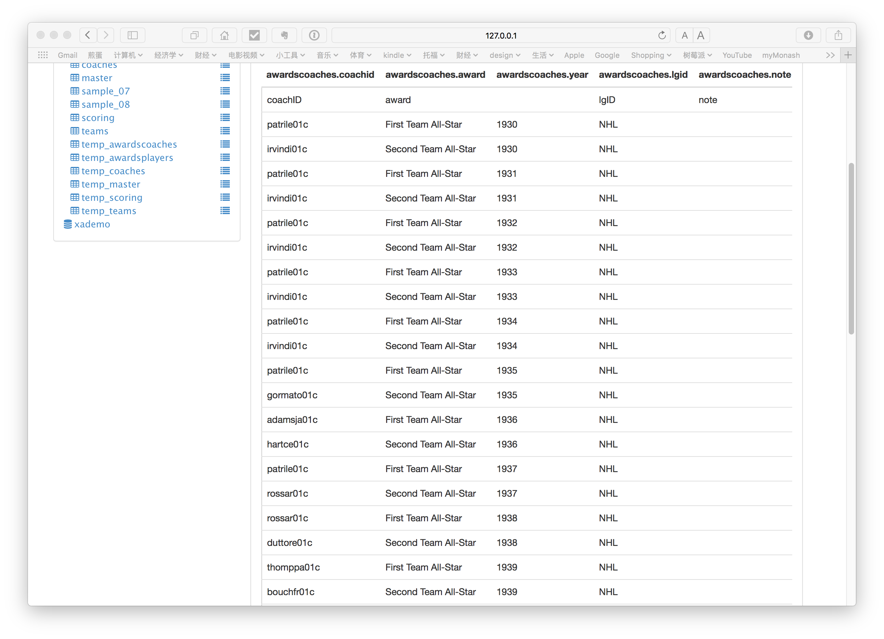

AwardsPlayers Table

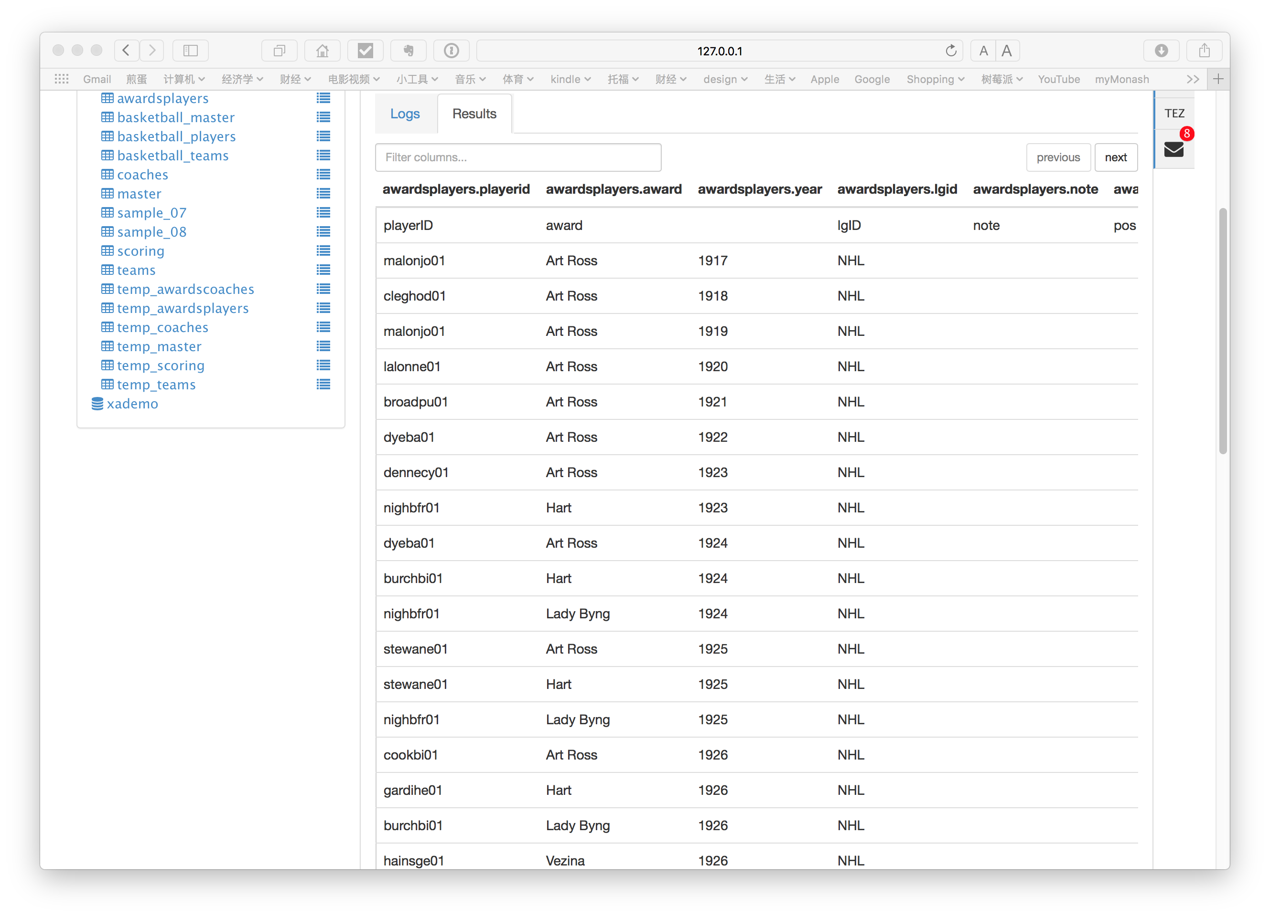

Coaches Table

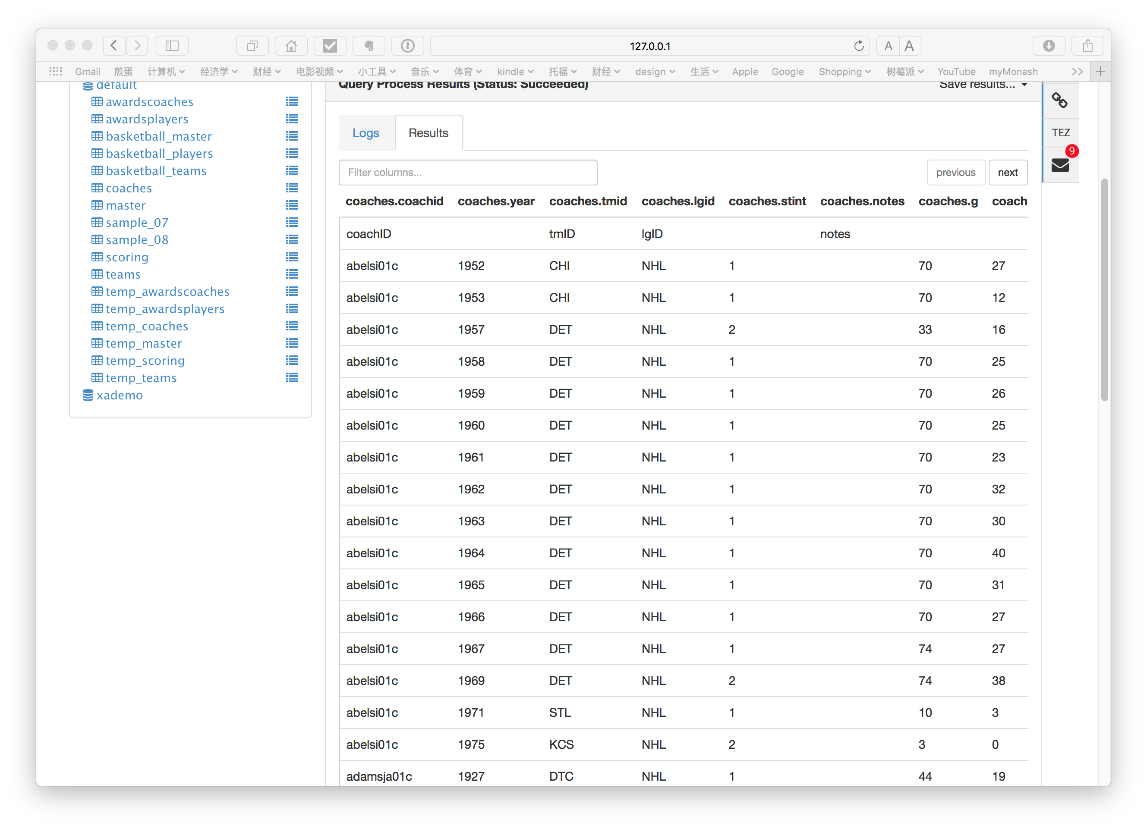

Master table

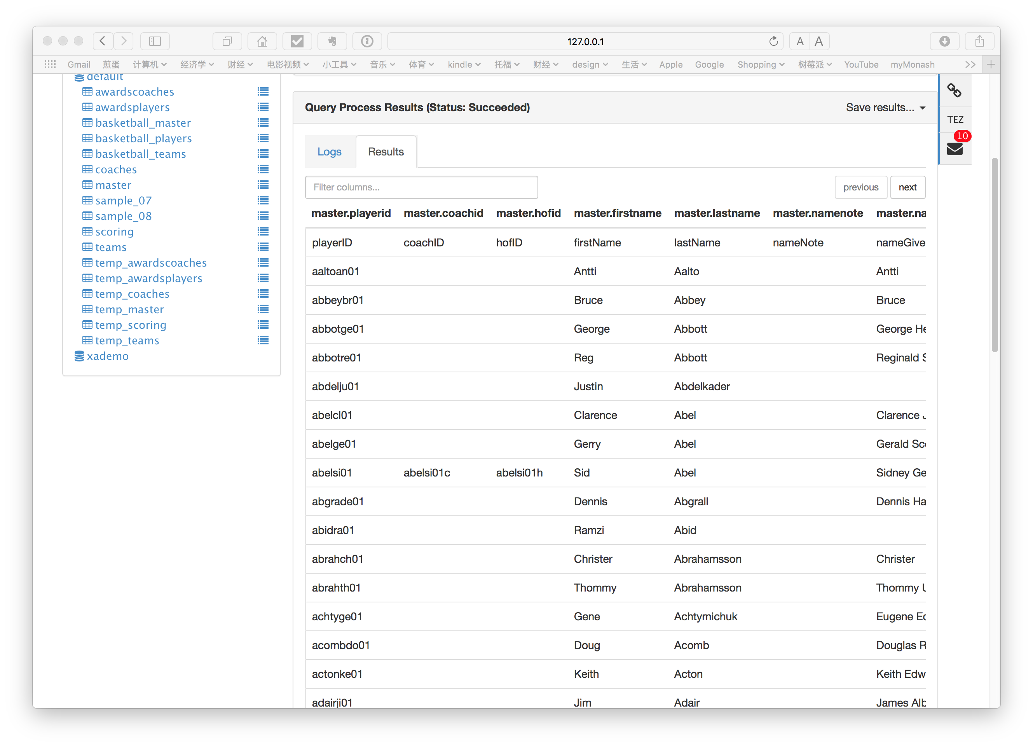

Scoring Table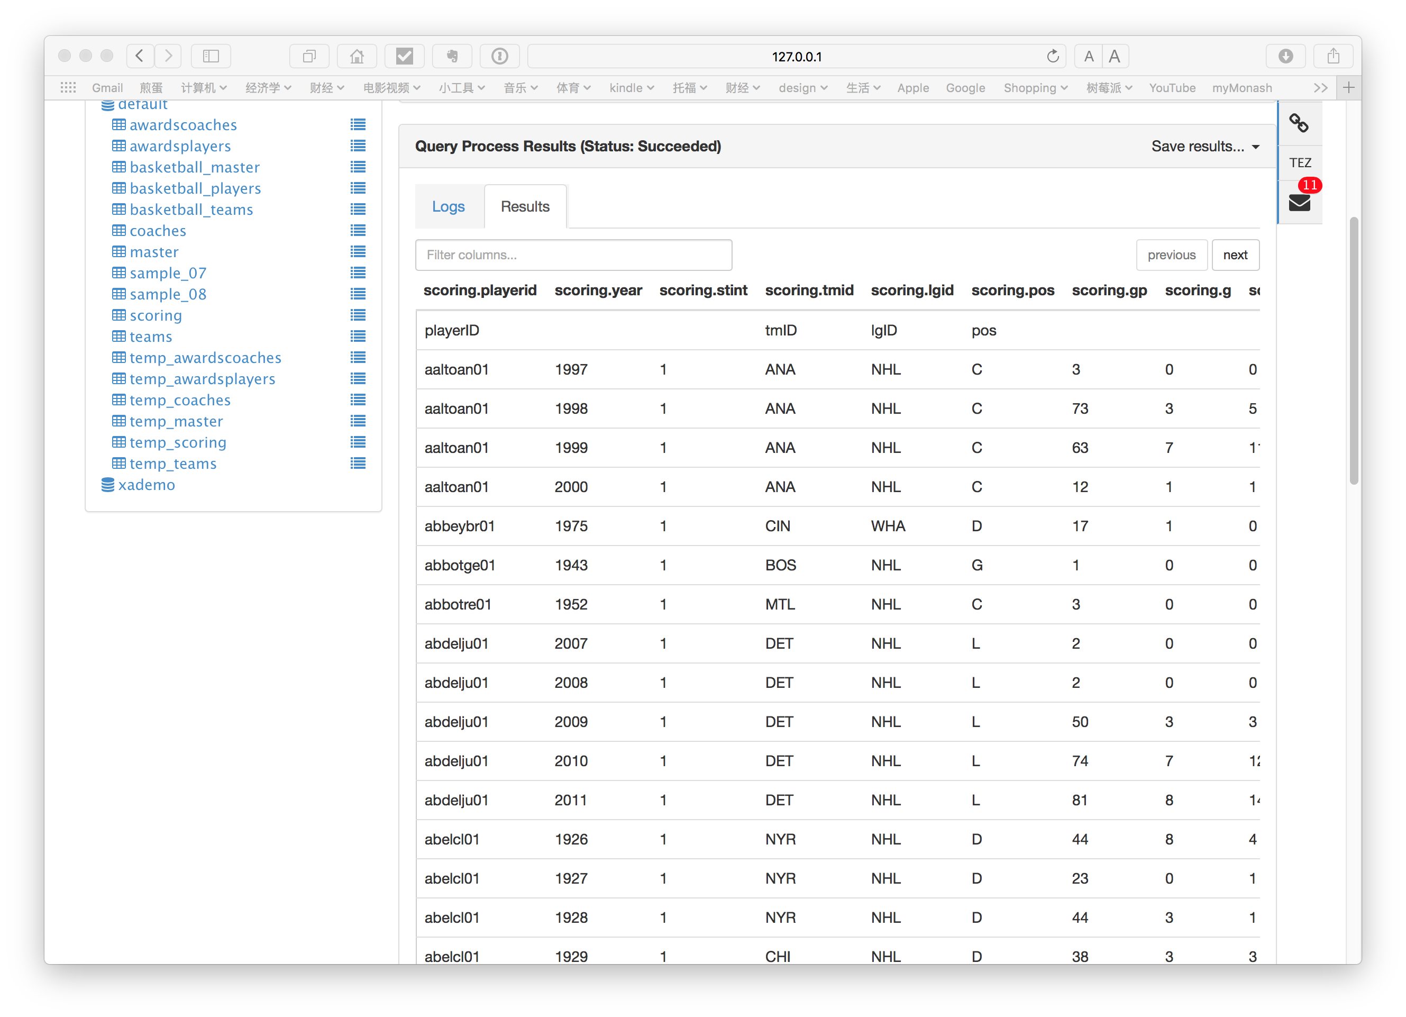

Teams

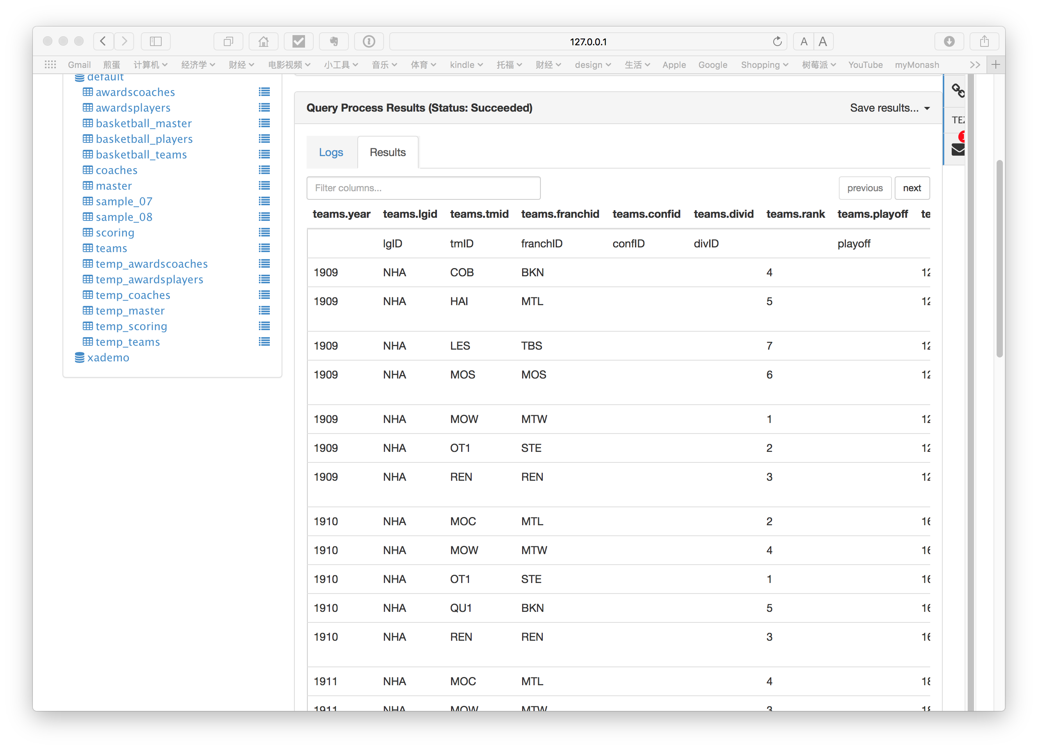

Pig:

AwardsCoaches table

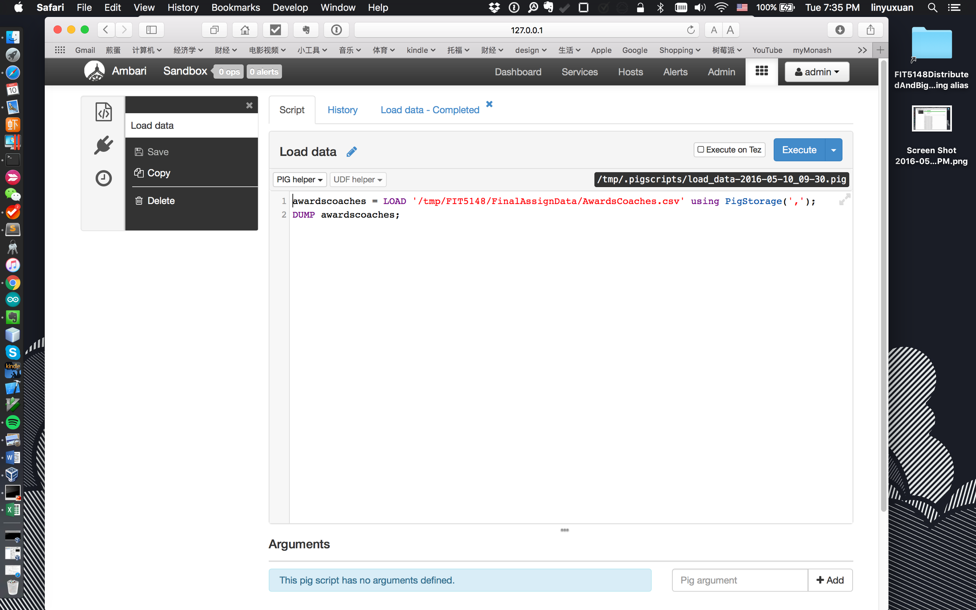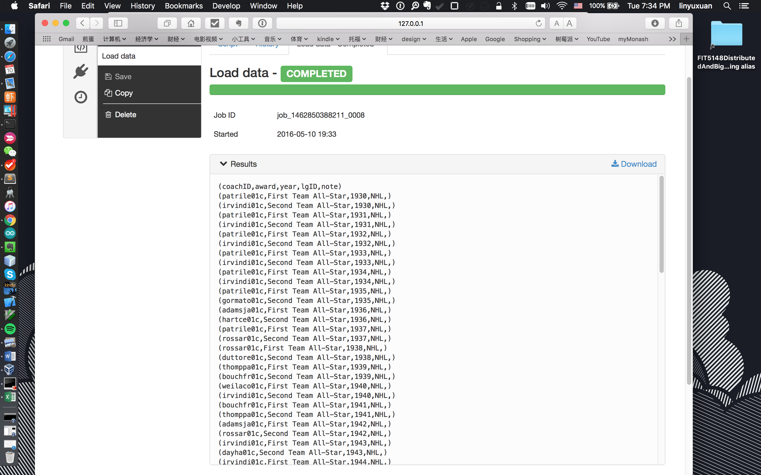

AwardsPlayers table

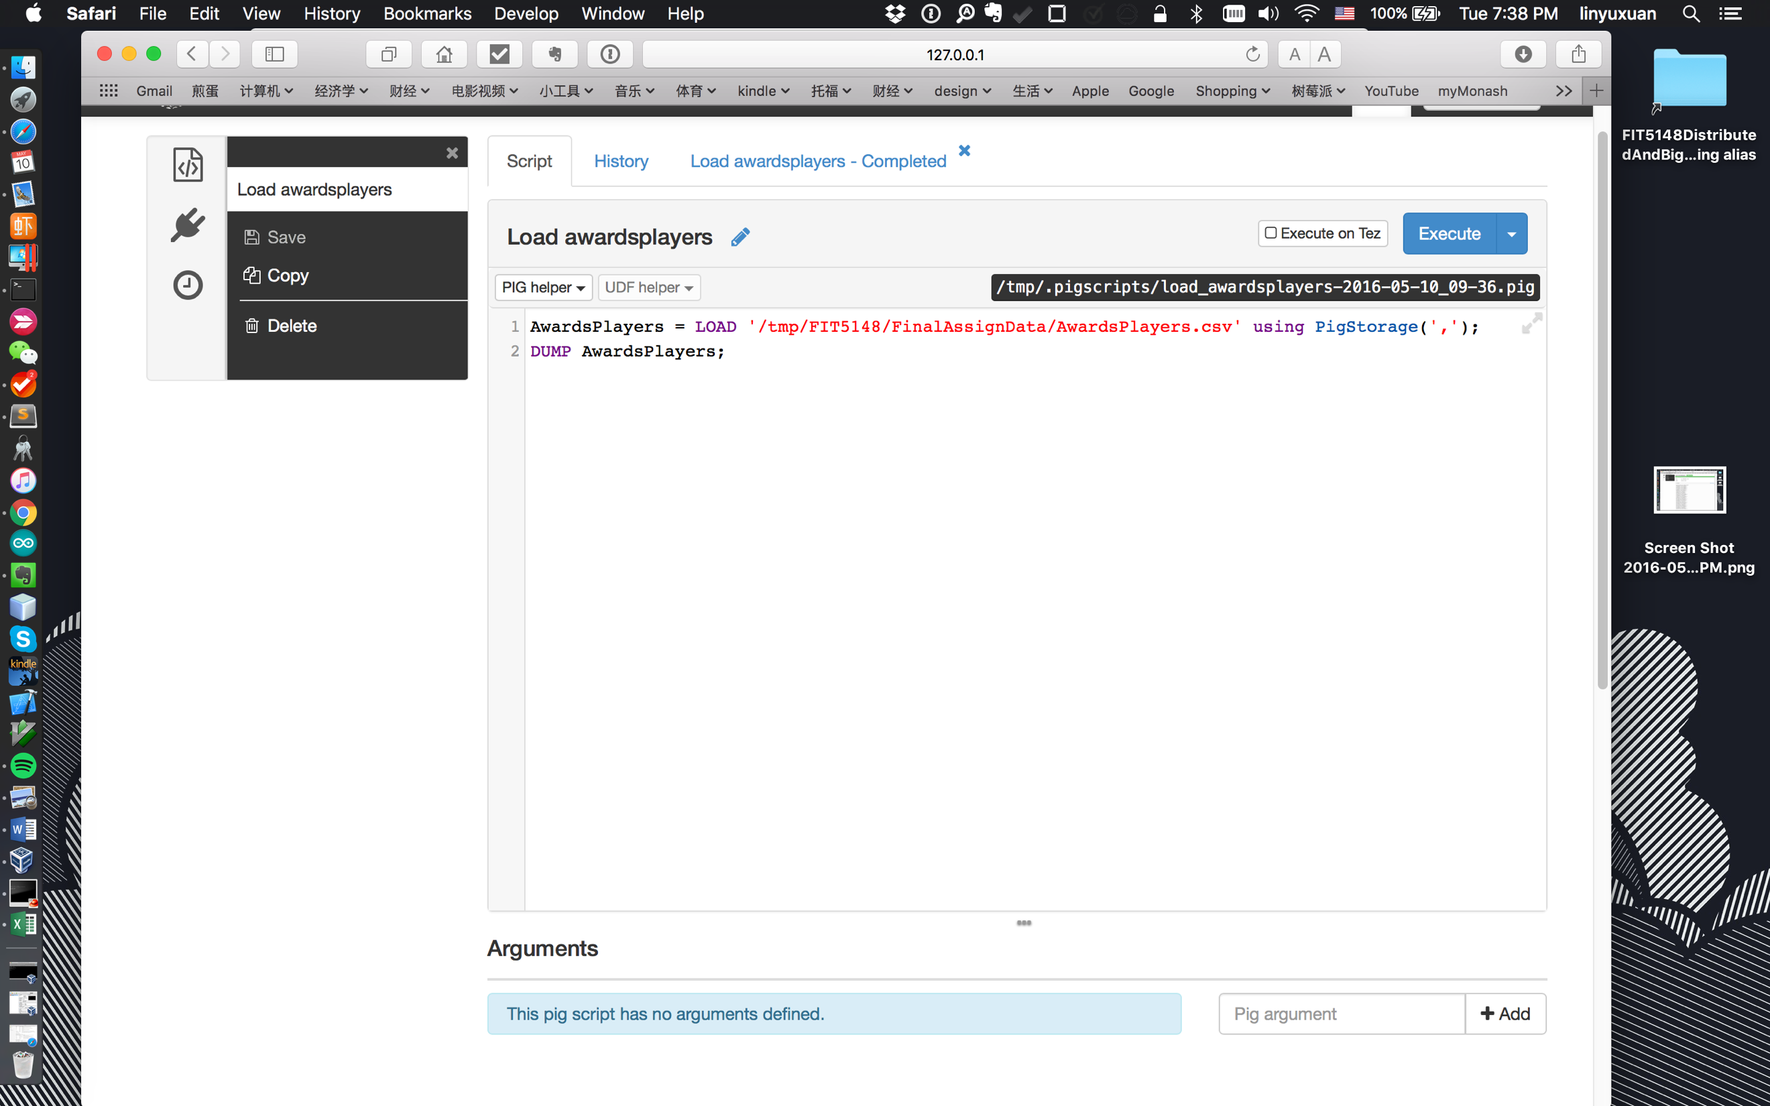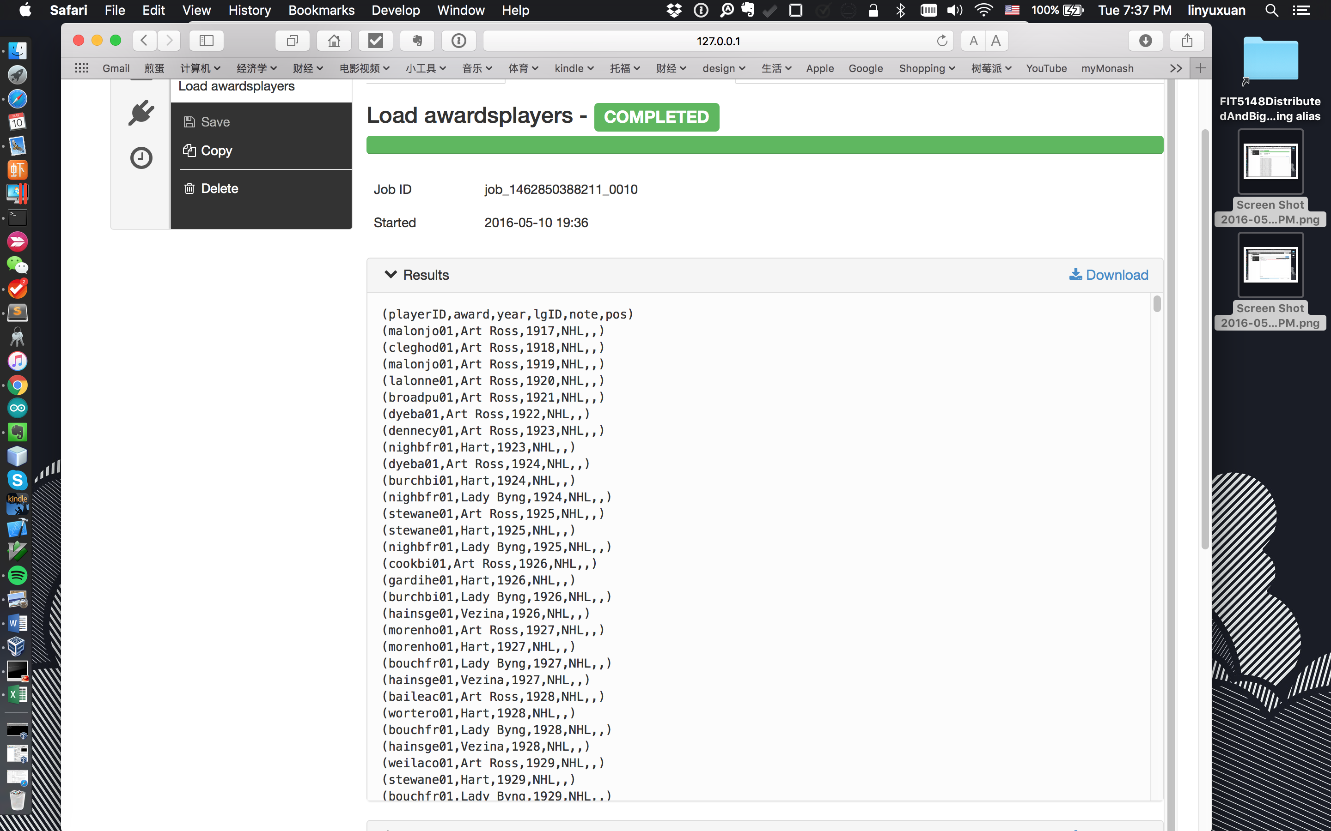

Coaches table

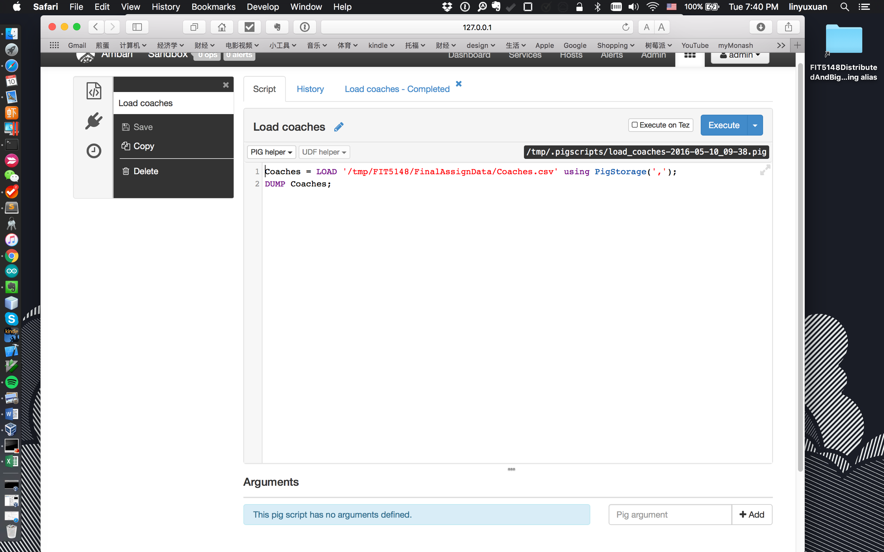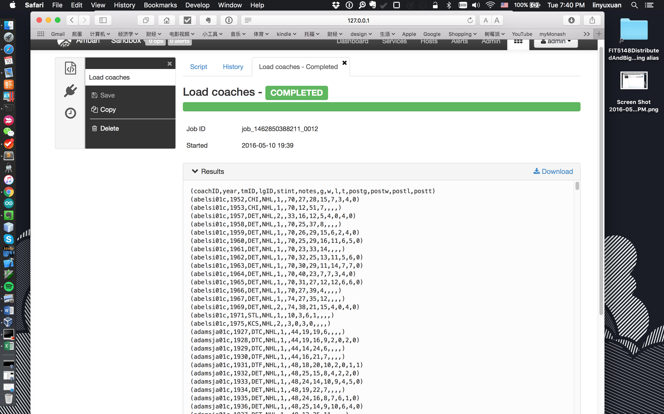

Master table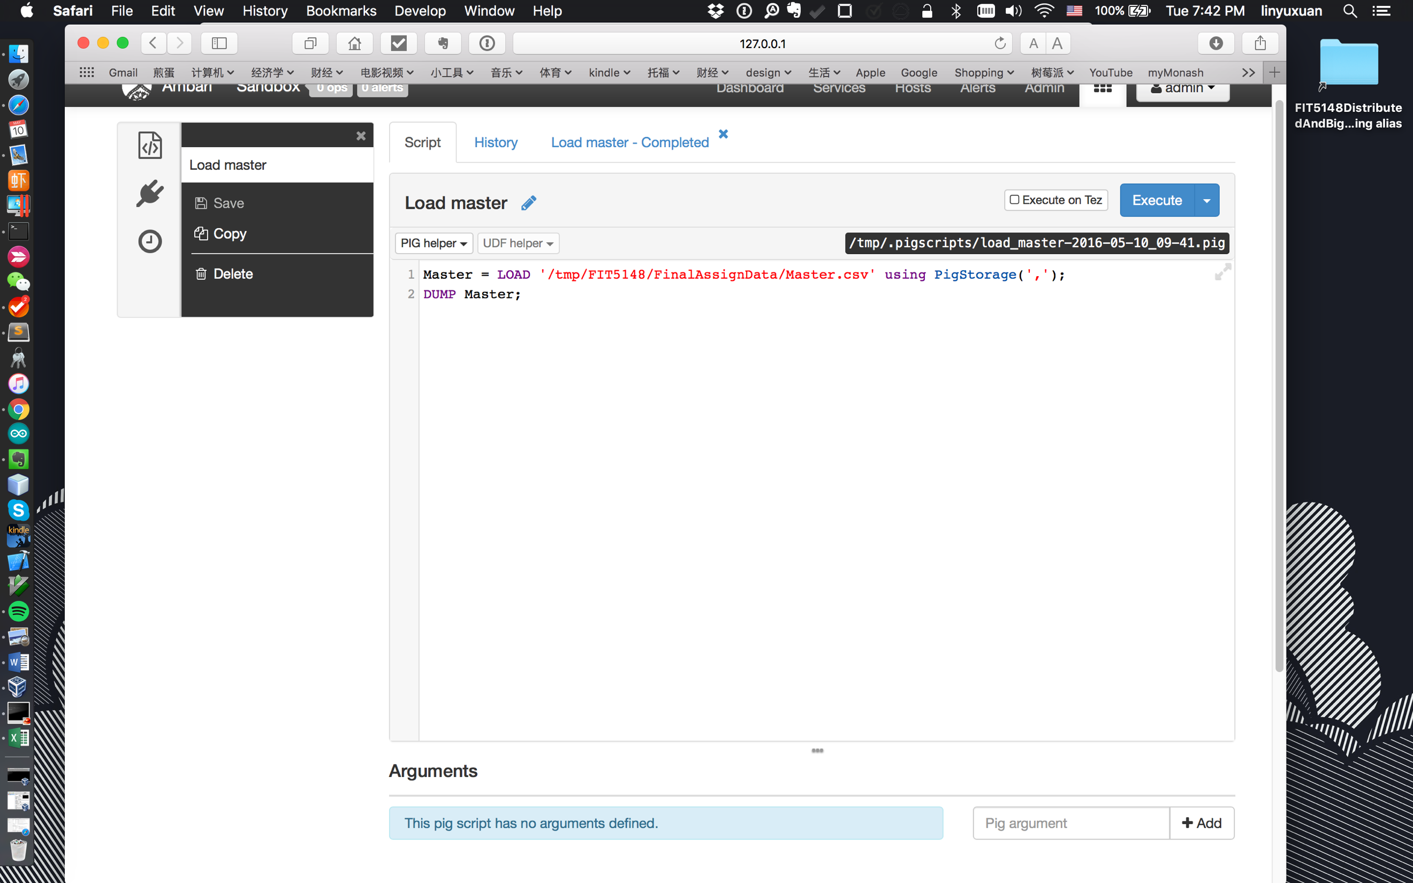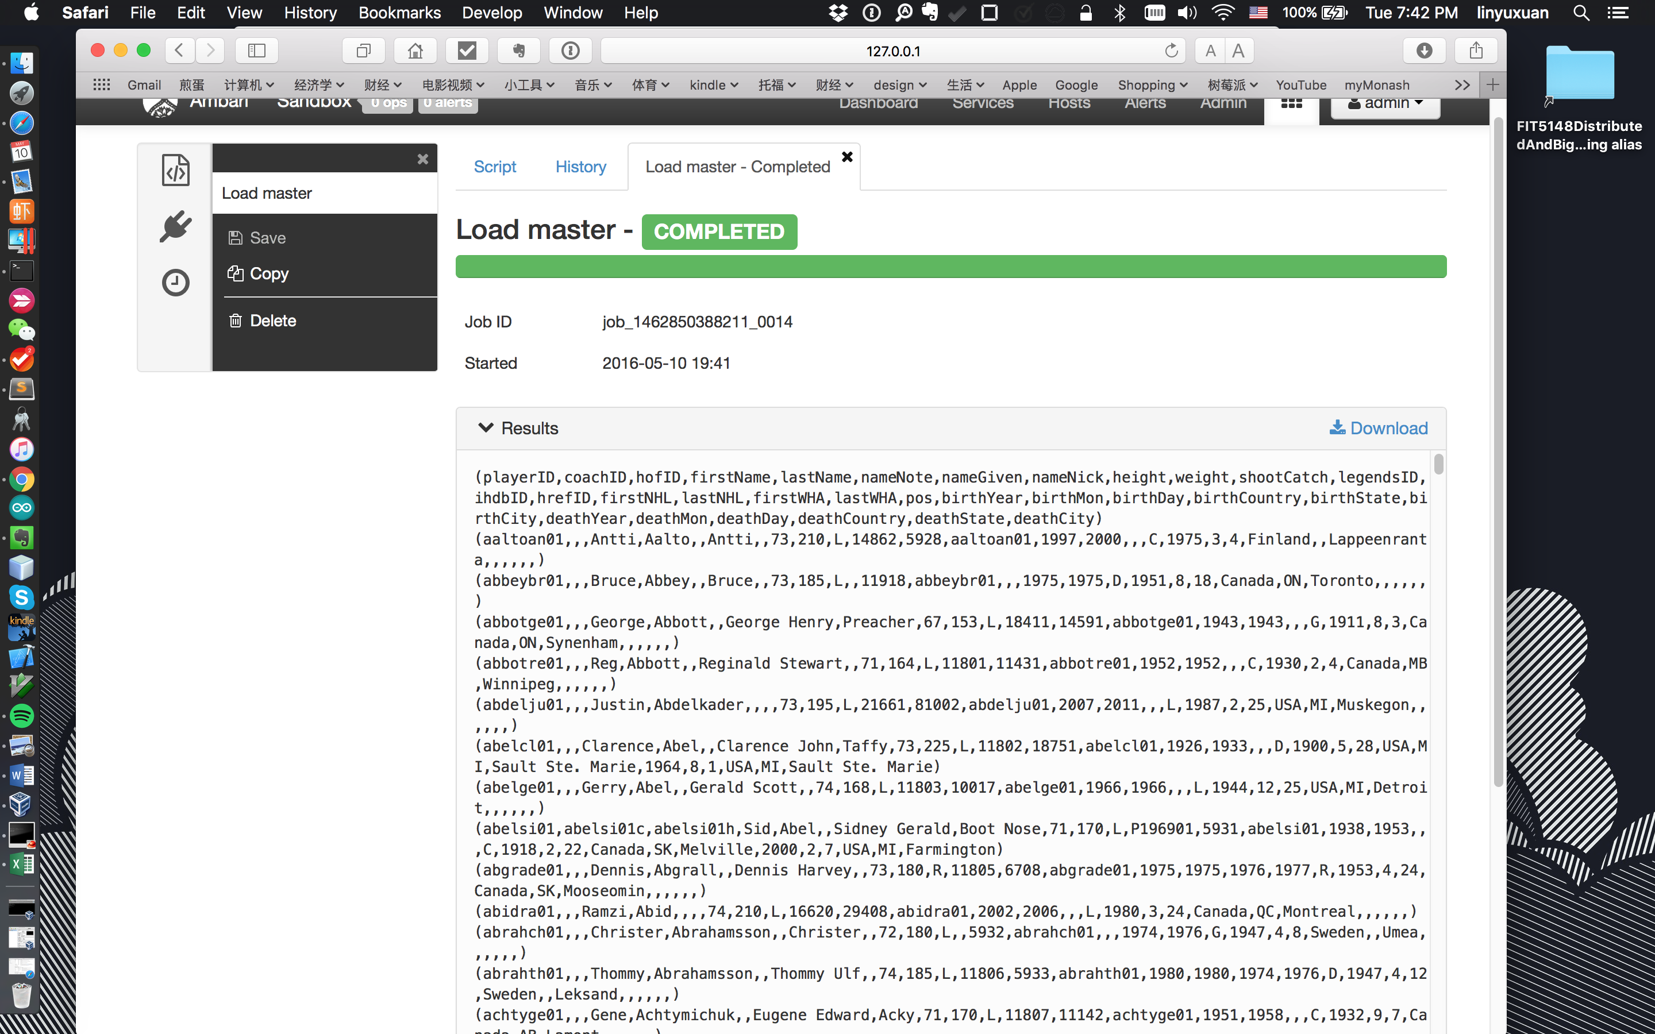

Scoring table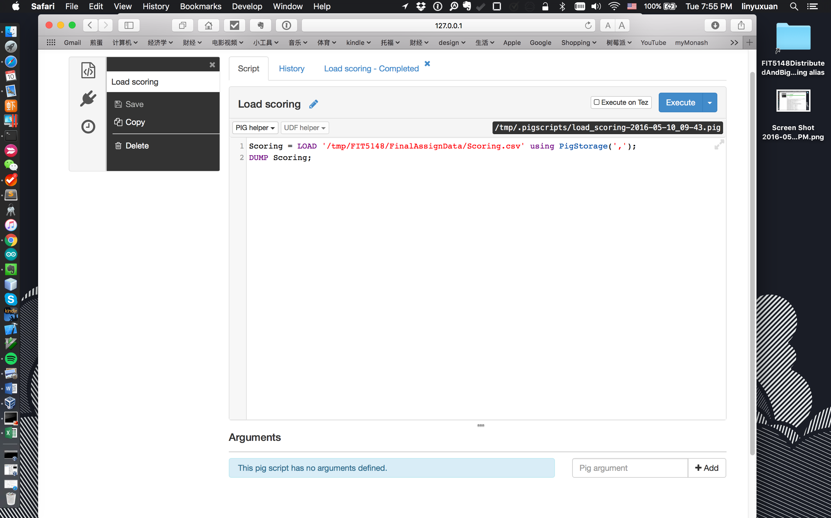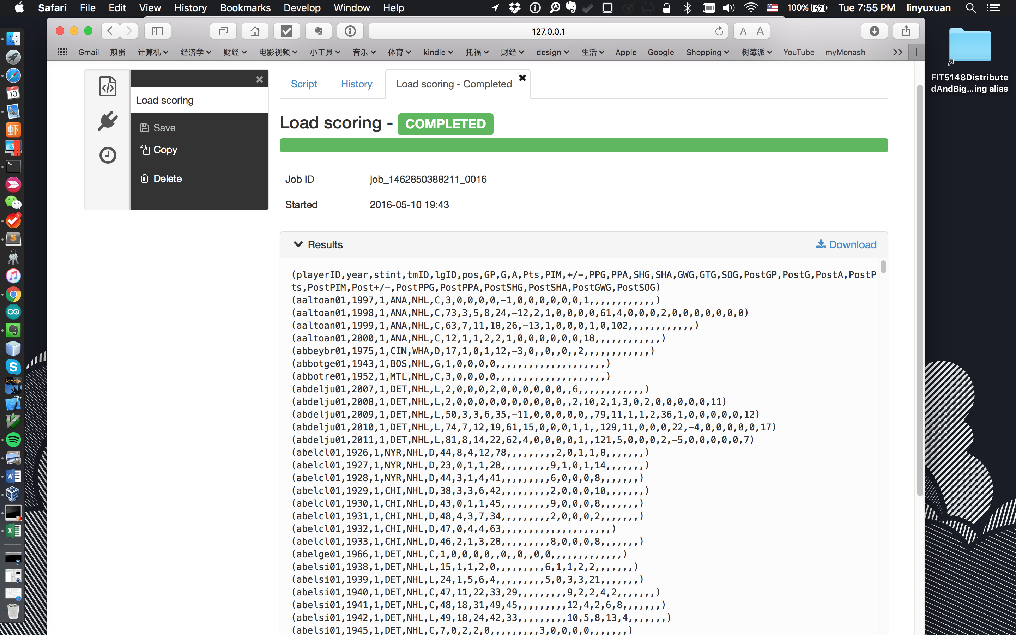

Teams table

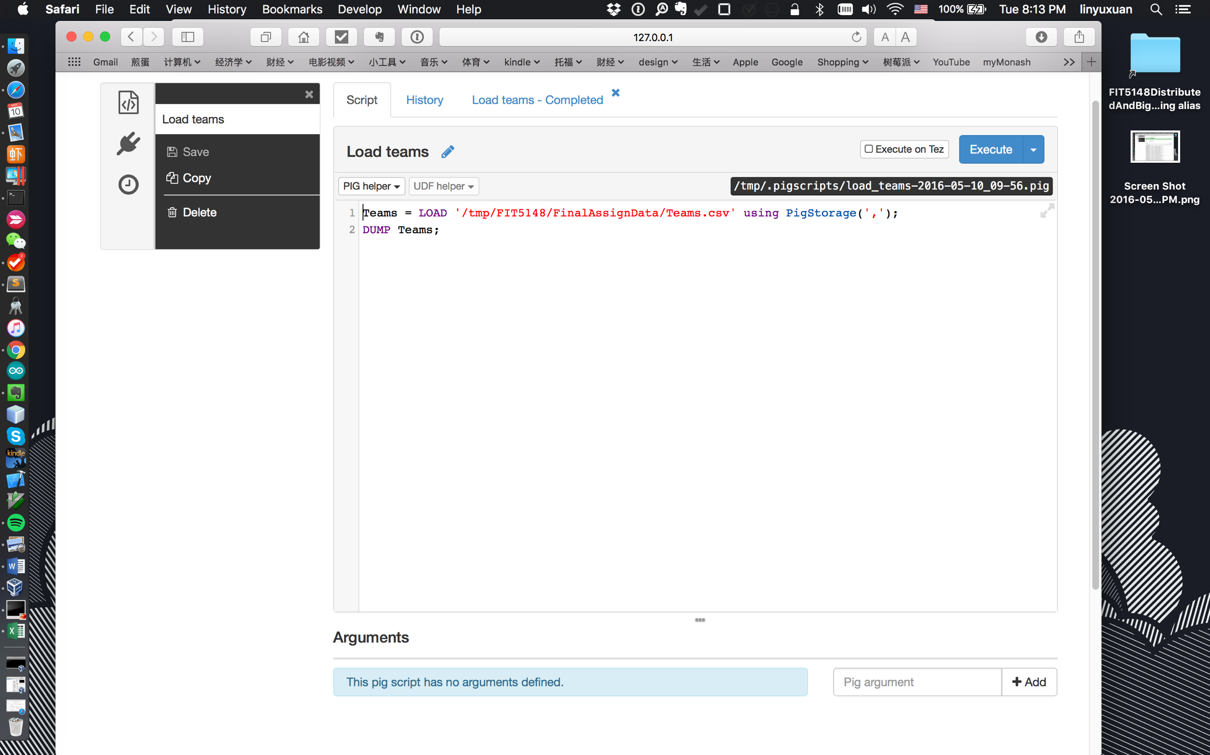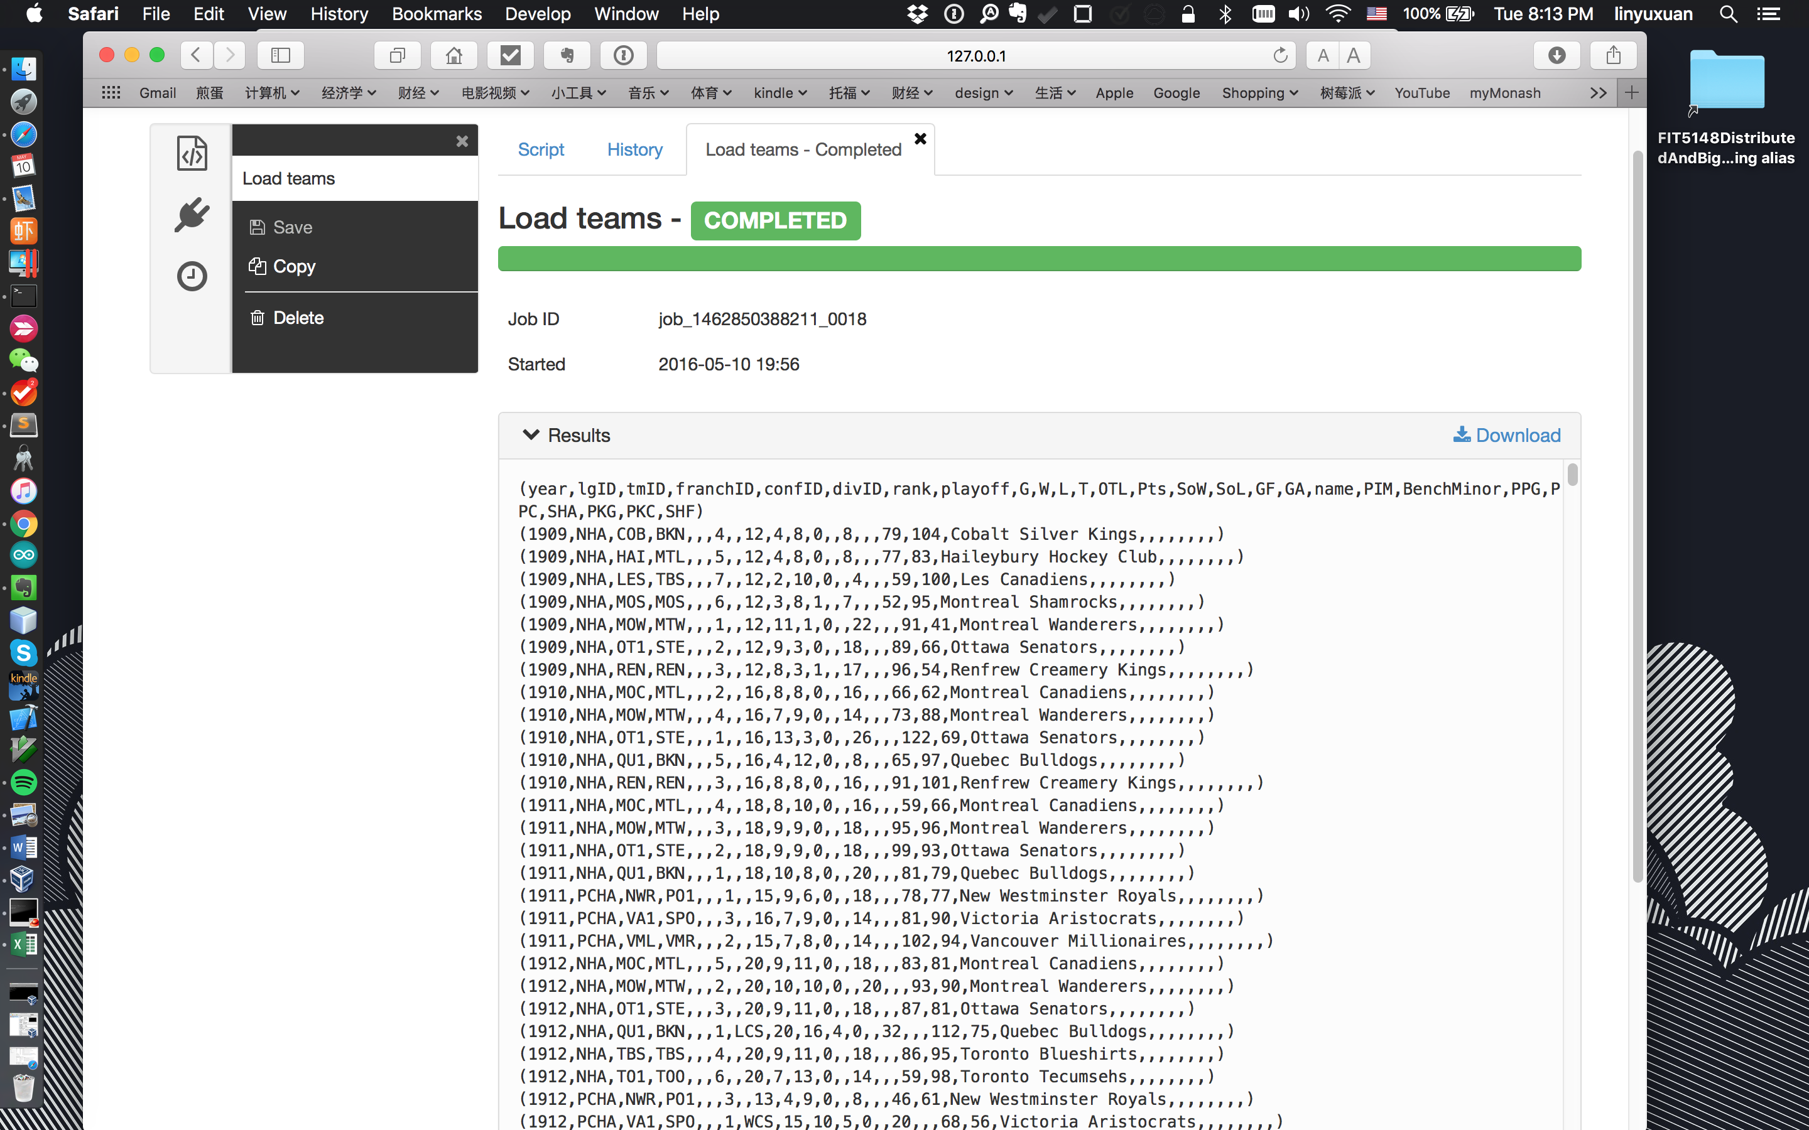

**Task 2 Players (6 marks):**

* a)  Find out the player/s who had the highest GWG (you can repeat a player if the year is different). In the query results show the following details: year, player first and last names, date of birth (day, month and year), country of birth, and team name and league ID, their positions, and GWG.

Hive:

SELECT

s.gwg as MaxGWG, s.year as year, s.pos,

m.firstname, m.lastname, m.birthday, m.birthmon, m.birthyear,m.birthcountry

FROM scoring s

JOIN (SELECT max(gwg) as gwg FROM scoring ) max

ON (s.gwg = max.gwg)

JOIN master m

ON (s.playerid = m.playerid)

JOIN teams t

ON (t.tmid = s.tmid and t.year = s.year);

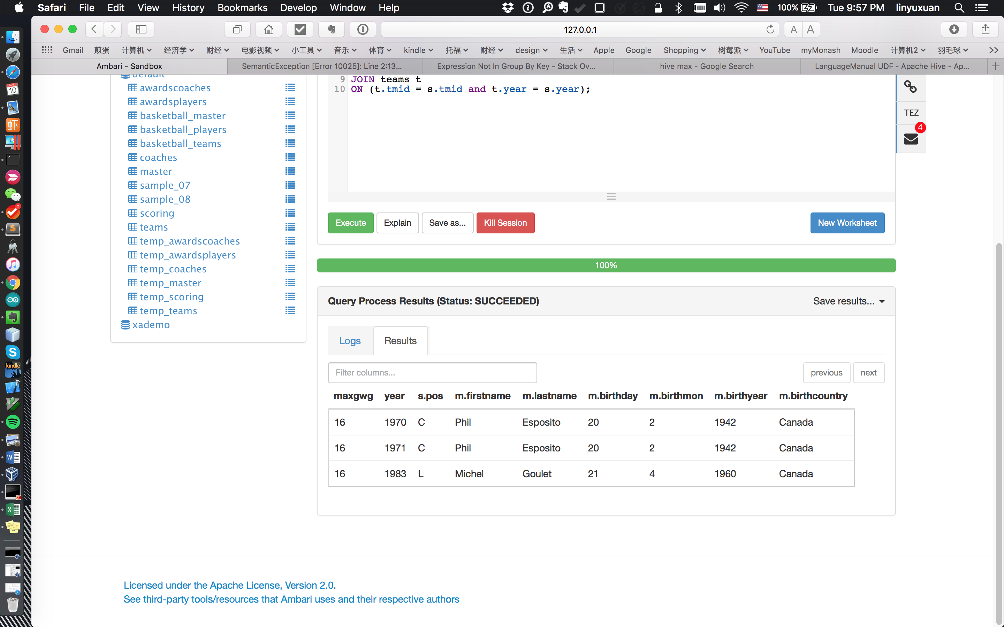

Pig:

s_raw = LOAD 'scoring'

using org.apache.hive.hcatalog.pig.HCatLoader();

t = LOAD 'teams'

using org.apache.hive.hcatalog.pig.HCatLoader();

m = LOAD 'master'

using org.apache.hive.hcatalog.pig.HCatLoader();

master = FOREACH m GENERATE $0 as playerid, $3 as fname, $4 as lname, $19 as byear, $20 as bmon, $21 as bday, $22 as bcountry;

s_gwg = FOREACH s_raw

GENERATE $16 as gwg, $1 as year,$5 as pos, $0 as playerid, $3 as tmid;

s_gwg_group = GROUP s_gwg ALL;--Important

max_gwg = FOREACH s_gwg_group

GENERATE MAX(s_gwg.gwg) as mgwg;

join_gwg = JOIN max_gwg by ($0), s_gwg by ($0);

gwg_2 = FOREACH join_gwg GENERATE $1 as gwg, $2 as year, $3 as pos, $4 as playerid, $5 as tmid;

join_player = JOIN gwg_2 by ($3), master by ($0);

players = FOREACH join_player GENERATE $0 as gwg, $1 as year, $2 as pos, $3 as playerid, $4 as tmid,$6 as fname, $7 as lname, $8 as byear, $9 as bmon, $10 as bday, $11 as bcountry;

DUMP join_player;

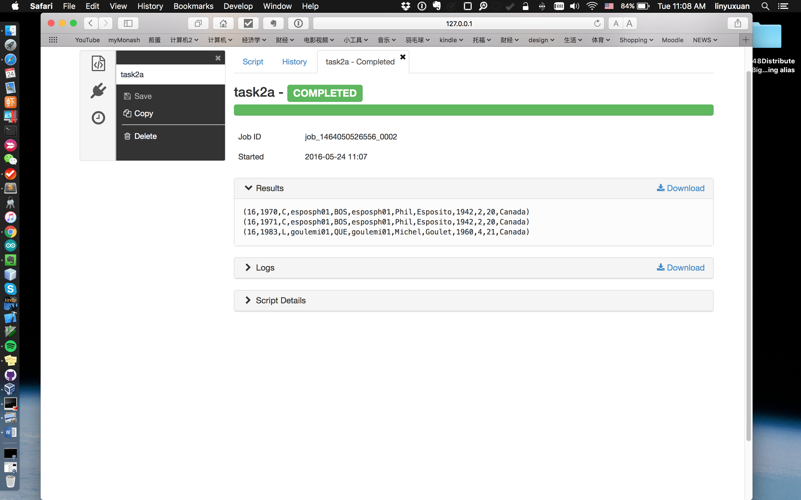

Time consuming and details:

Hive:

17 sec

Using map reduce.

Pig:

52 sec

Run under Tez, with no maps and reduces.

* b)  Among those player/s who had the highest GWG, find out the player who had won the highest number of awards. In the query results show the following details: player first and last name, and award count.

Hive:

select

counts.awards as awardcount, master.firstname as fname, master.lastname as lname

from

(select

count(award) as awards, playerid

from awardsplayers

group by playerid) as counts

JOIN

(select max(counts.awards) as maxawards

from

(select

count(x.award) as awards, x.playerid as playerid

from

(SELECT a.award as award, a.playerid as playerid

FROM

awardsplayers a

JOIN

(SELECT

DISTINCT m.playerid, m.firstname, m.lastname

FROM scoring s

JOIN (SELECT max(gwg) as gwg FROM scoring ) max

ON (s.gwg = max.gwg)

JOIN master m

ON (s.playerid = m.playerid)) k

ON (a.playerid = k.playerid)) x

group by x.playerid) as counts) as max

ON (counts.awards = max.maxawards)

JOIN

master

ON (master.playerid = counts.playerid)

;

Result screenshot:

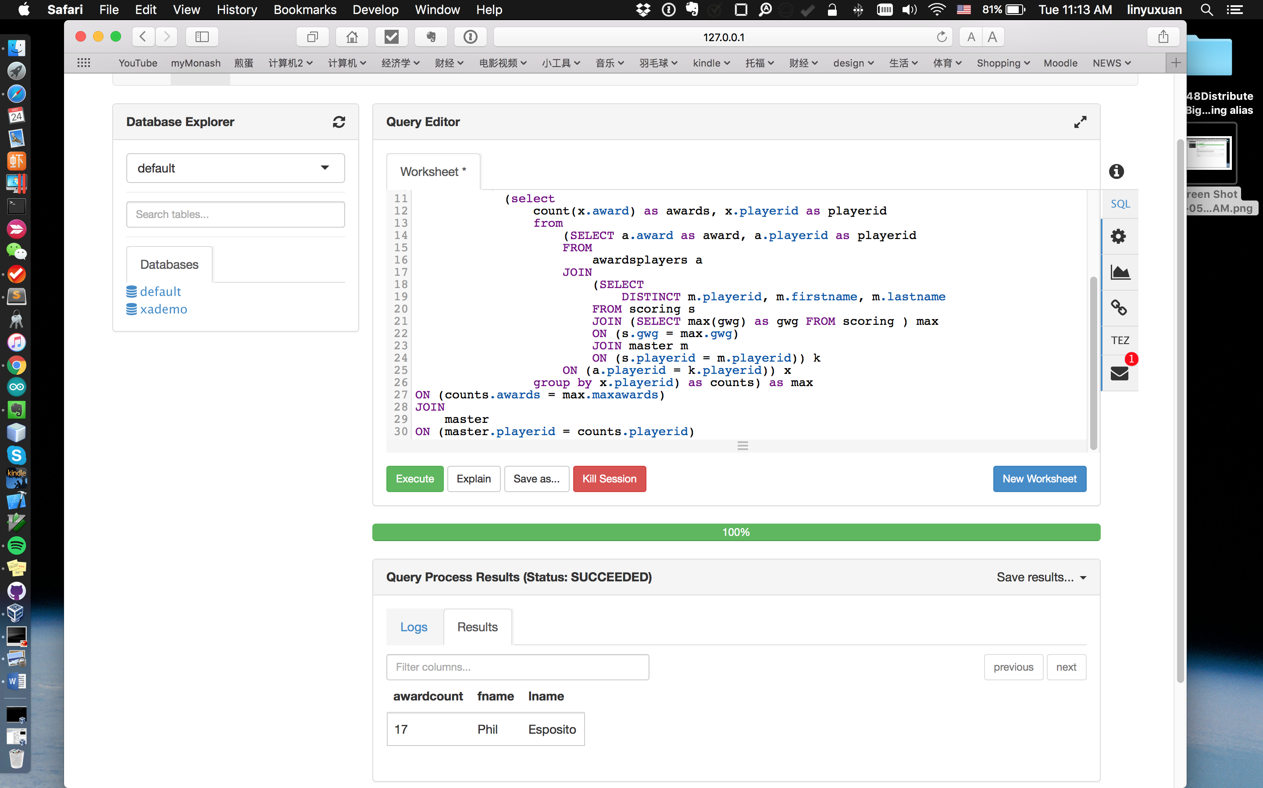

Pig script:

s_raw = LOAD 'scoring'

using org.apache.hive.hcatalog.pig.HCatLoader();

t = LOAD 'teams'

using org.apache.hive.hcatalog.pig.HCatLoader();

m = LOAD 'master'

using org.apache.hive.hcatalog.pig.HCatLoader();

master = FOREACH m GENERATE $0 as playerid, $3 as fname, $4 as lname, $19 as byear, $20 as bmon, $21 as bday, $22 as bcountry;

s_gwg = FOREACH s_raw

GENERATE $16 as gwg, $1 as year,$5 as pos, $0 as playerid, $3 as tmid;

s_gwg_group = GROUP s_gwg ALL;--Important

max_gwg = FOREACH s_gwg_group

GENERATE MAX(s_gwg.gwg) as mgwg;

join_gwg = JOIN max_gwg by ($0), s_gwg by ($0);

gwg_2 = FOREACH join_gwg GENERATE $1 as gwg, $2 as year, $3 as pos, $4 as playerid, $5 as tmid;

join_player = JOIN gwg_2 by ($3), master by ($0);

players = FOREACH join_player GENERATE $3 as playerid, $6 as fname, $7 as lname;

players_d = DISTINCT players;

--players: GWG ----------------------------------

ap_raw = LOAD 'awardsplayers'

using org.apache.hive.hcatalog.pig.HCatLoader();

ap_raw2 = FOREACH ap_raw GENERATE $0 as playerid, $1 as award;--Awards表

ap_group = GROUP ap_raw2 BY playerid;

ap_group_count = FOREACH ap_group GENERATE COUNT(ap_raw2) as awardscount, ap_raw2.playerid as playerid;

C = FOREACH ap_group_count GENERATE $0 as awardscount, FLATTEN($1);

X = ORDER C BY $0 DESC;

M = JOIN X BY ($1), players_d BY ($0);

Z = LIMIT M 1;

N = FOREACH Z GENERATE $0 AS awardcount, $3, $4;

DUMP N;

Result screenshot:

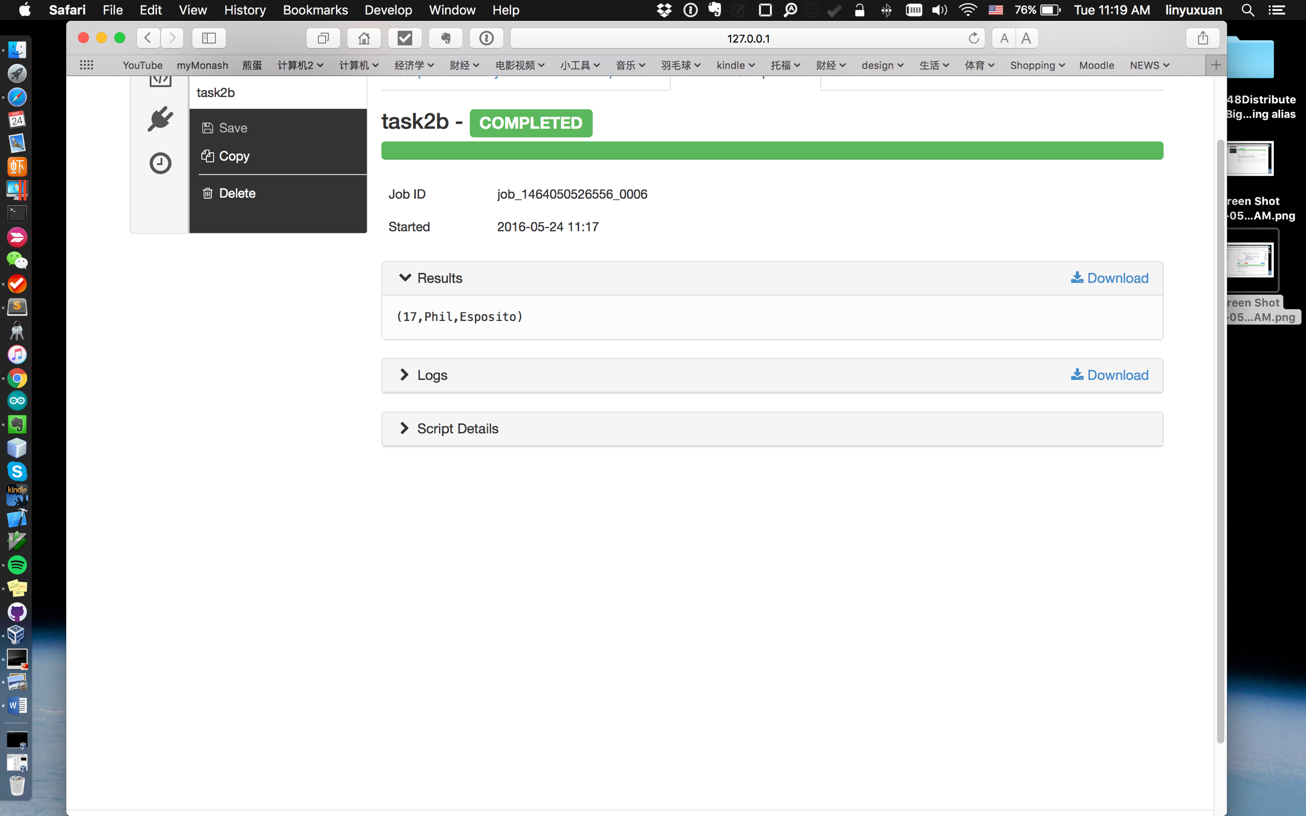

Time consuming and details:

Hive:

21 sec

With maps and reducers and Tez on.

Pig:

1 min, 2 sec

No maps and reducers, with Tez on.

* c) Then using the first and last name of the player who had won the highest number of awards find out the points that the player had earned for each year that the player received an award. Display the following details: the award names, the award year, and the points/Pts that the player scored that year.

Hive script:

SELECT award_table.award, award_table.year, pts_sum.pts_sum

FROM

(SELECT ap.playerid as playerid, ap.award as award, ap.year as year

FROM awardsplayers ap

JOIN

(SELECT master.playerid as playerid

FROM master

JOIN

(select

counts.awards as awardcount, master.firstname as fname, master.lastname as lname

from

(select

count(award) as awards, playerid

from awardsplayers

group by playerid) as counts

JOIN

(select max(counts.awards) as maxawards

from

(select

count(x.award) as awards, x.playerid as playerid

from

(SELECT a.award as award, a.playerid as playerid

FROM

awardsplayers a

JOIN

(SELECT

DISTINCT m.playerid, m.firstname, m.lastname

FROM scoring s

JOIN (SELECT max(gwg) as gwg FROM scoring ) max

ON (s.gwg = max.gwg)

JOIN master m

ON (s.playerid = m.playerid)) k

ON (a.playerid = k.playerid)) x

group by x.playerid) as counts) as max

ON (counts.awards = max.maxawards)

JOIN

master

ON (master.playerid = counts.playerid)) player

ON (master.firstname = player.fname and master.lastname = player.lname)) id

ON (ap.playerid = id.playerid)) award_table

JOIN

(SELECT SUM(pts_id.pts) as pts_sum, pts_id.year as year-- point sum, year

FROM

(SELECT scoring.pts, scoring.year, scoring.playerid

FROM scoring

JOIN

(SELECT master.playerid as playerid

FROM master

JOIN

(select

counts.awards as awardcount, master.firstname as fname, master.lastname as lname

from

(select

count(award) as awards, playerid

from awardsplayers

group by playerid) as counts

JOIN

(select max(counts.awards) as maxawards

from

(select

count(x.award) as awards, x.playerid as playerid

from

(SELECT a.award as award, a.playerid as playerid

FROM

awardsplayers a

JOIN

(SELECT

DISTINCT m.playerid, m.firstname, m.lastname

FROM scoring s

JOIN (SELECT max(gwg) as gwg FROM scoring ) max

ON (s.gwg = max.gwg)

JOIN master m

ON (s.playerid = m.playerid)) k

ON (a.playerid = k.playerid)) x

group by x.playerid) as counts) as max

ON (counts.awards = max.maxawards)

JOIN

master

ON (master.playerid = counts.playerid)) player

ON (master.firstname = player.fname and master.lastname = player.lname)) id

ON(scoring.playerid = id.playerid)) pts_id

GROUP BY pts_id.year) pts_sum

ON (award_table.year = pts_sum.year)

;

Result screenshot:

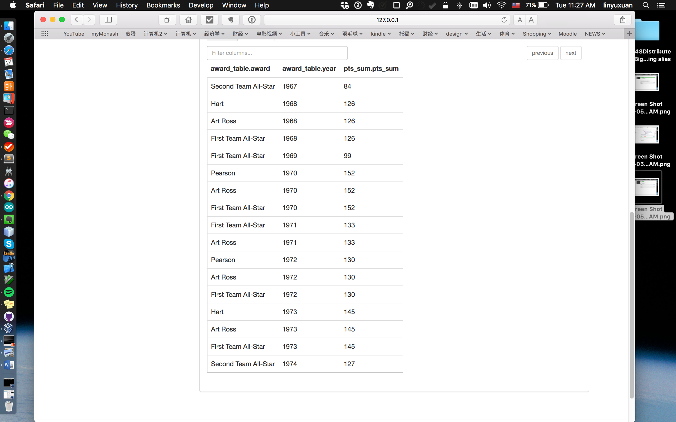

Pig script:

s_raw = LOAD 'scoring'

using org.apache.hive.hcatalog.pig.HCatLoader();

t = LOAD 'teams'

using org.apache.hive.hcatalog.pig.HCatLoader();

m = LOAD 'master'

using org.apache.hive.hcatalog.pig.HCatLoader();

master = FOREACH m GENERATE $0 as playerid, $3 as fname, $4 as lname, $19 as byear, $20 as bmon, $21 as bday, $22 as bcountry;

s_gwg = FOREACH s_raw

GENERATE $16 as gwg, $1 as year,$5 as pos, $0 as playerid, $3 as tmid;

s_gwg_group = GROUP s_gwg ALL;--Important

max_gwg = FOREACH s_gwg_group

GENERATE MAX(s_gwg.gwg) as mgwg;

join_gwg = JOIN max_gwg by ($0), s_gwg by ($0);

gwg_2 = FOREACH join_gwg GENERATE $1 as gwg, $2 as year, $3 as pos, $4 as playerid, $5 as tmid;

join_player = JOIN gwg_2 by ($3), master by ($0);

players = FOREACH join_player GENERATE $3 as playerid, $6 as fname, $7 as lname;

players_d = DISTINCT players;

--players: GWG最高的选手----------------------------------

ap_raw = LOAD 'awardsplayers'

using org.apache.hive.hcatalog.pig.HCatLoader();

ap_raw2 = FOREACH ap_raw GENERATE $0 as playerid, $1 as award;--Awards表

ap_group = GROUP ap_raw2 BY playerid;

ap_group_count = FOREACH ap_group GENERATE COUNT(ap_raw2) as awardscount, ap_raw2.playerid as playerid;

C = FOREACH ap_group_count GENERATE $0 as awardscount, FLATTEN($1);

X = ORDER C BY $0 DESC;

M = JOIN X BY ($1), players_d BY ($0);

Z = LIMIT M 1;-- Z: (17,esposph01,esposph01,Phil,Esposito)

N = FOREACH Z GENERATE $0 AS awardcount, $3, $4;-- N: (17,Phil,Esposito)

p_id_join = JOIN N BY ($1, $2), m BY ($3, $4);--($3 ID)

-- Find playerID from Master by firstname and lastname;

p_id = FOREACH p_id_join GENERATE $3 as playerid; --p_id: (esposph01)

ap_year = FOREACH ap_raw GENERATE $0 as playerid, $1 as award, $2 as year;

-- Find all awards, year(distinct) from AwardsPlayers table with the playerID;

award_join = JOIN p_id by ($0), ap_year by ($0); --(esposph01,esposph01,First Team All-Star,1969)

-- DUMP award_join;

scoring = FOREACH s_raw GENERATE $0 as playerid, $1 as year, $9 as pts; --scoring:(playerid, year,pts)

scoring_filter_raw = JOIN scoring by ($0), p_id by($0);--scoring_filter(esposph01,1975,67,esposph01)

-- SUM points by year and id from scoring_filter;

scoring_filter = FOREACH scoring_filter_raw GENERATE $0 as playerid, $1 as year, $2 as pts;--scoring_filter(esposph01,1975,67)

scoring_filter_gb_year = GROUP scoring_filter BY year;

sum_scoring_by_year = FOREACH scoring_filter_gb_year GENERATE group as year, SUM(scoring_filter.pts) as sumpts;

final_raw = JOIN award_join by ($3), sum_scoring_by_year by ($0);--(esposph01,esposph01,Second Team All-Star,1967,1967,84)

final = FOREACH final_raw GENERATE $2 as award, $3 as year, $5 as pts;

final_o = ORDER final BY year;

DUMP final_o;

Result screenshot:

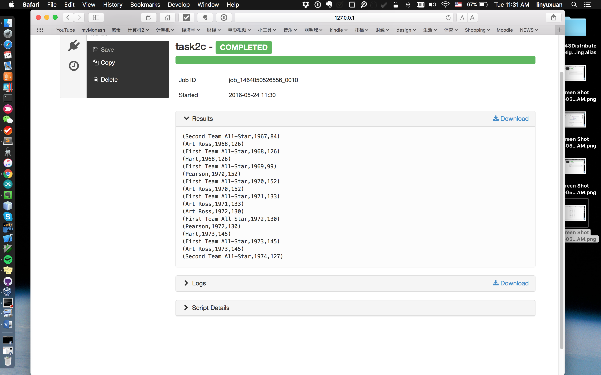

Time consuming and details:

Hive:

27 secs

With Tez, maps and reducers.

Pig:

1 min, 2 sec

Using Tez, no maps and reducers.

* **Task 3 Coaches (6 marks):**
* a) Find out the coach who had won the highest number of awards. In the query results show the following details: coach first and last name, date of birth, birth country and number of awards.
* Hive script:
* SELECT
* pre.maxawards, master.firstname, master.lastname, master.birthyear, master.birthmon, master.birthday, master.birthcountry
* FROM
* (SELECT max.maxawards as maxawards, awardscounts_2.coachid as coachid
* FROM
* (SELECT count(award) as num_awards,coachid
* FROM awardscoaches
* GROUP BY (coachid)
* ) awardscounts_2
* JOIN
* (SELECT MAX(awardscounts.num_awards) as maxawards
* FROM
* (SELECT count(award) as num_awards,coachid
* FROM awardscoaches
* GROUP BY (coachid)
* ) awardscounts
* ) max
* ON (awardscounts_2.num_awards = max.maxawards)
* ) pre
* JOIN master
* ON ( pre.coachid = master.coachid)
* ;
* Result screenshot:

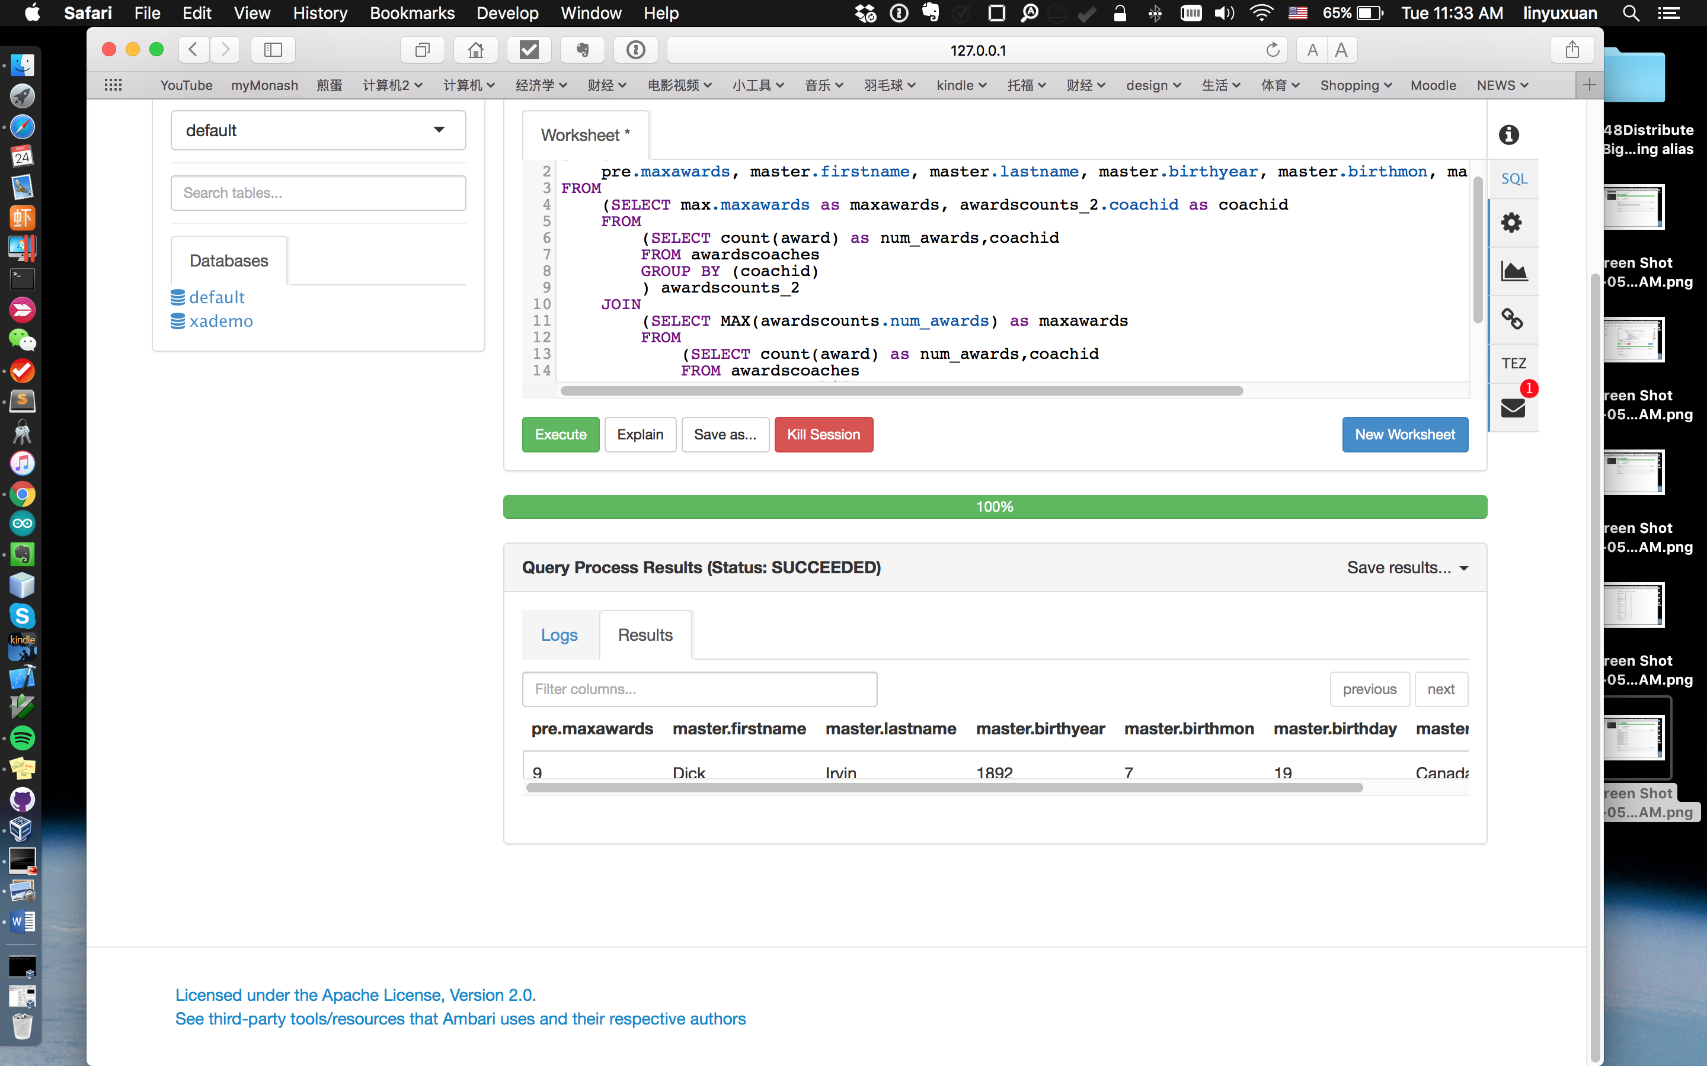

* Pig script:

ac_raw = LOAD 'awardscoaches'

using org.apache.hive.hcatalog.pig.HCatLoader();

-- coaches = LOAD 'coaches'

-- using org.apache.hive.hcatalog.pig.HCatLoader();

m = LOAD 'master'

using org.apache.hive.hcatalog.pig.HCatLoader();

ac = FOREACH ac_raw GENERATE $0 as coachid, $1 as award, $2 as year;

ms = FOREACH m GENERATE $1 as coachid, $3 as fname, $4 as lname, $19 as byear, $20 as bmon, $21 as bday, $22 as bcountry;

--group and count awards of coach

ac_group = GROUP ac by coachid;

ac_count = FOREACH ac_group GENERATE group as coachid, COUNT(ac) as num_awards;

--sort coach and limit 1

ac_count_order = ORDER ac_count BY num_awards DESC;

ac_max = LIMIT ac_count_order 1; --(irvindi01c, count)

-- DUMP ac_max;

-- join coaches with last result

x = JOIN ac_max by ($0), ms by ($0);--(irvindi01c,9,irvindi01c,Dick,Irvin,1892,7,19,Canada)

final = FOREACH x GENERATE $3 ,$4,$5, $6, $7, $8, $1;

DUMP final;

* Result screenshot:
* 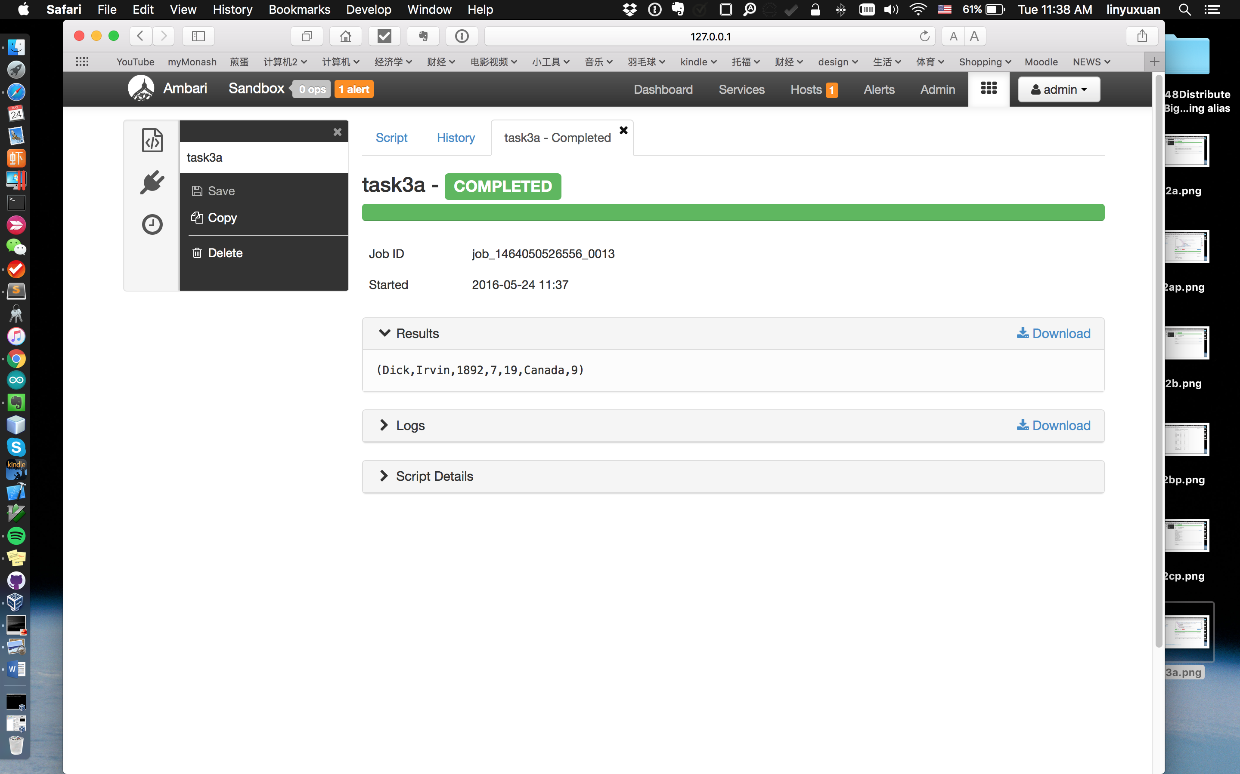
* Time consuming and details:
* Hive:
* 14 secs
* With Tez on, maps and reducers.
* Pig:
* 51 secs
* Using Tez on, no maps and reducers.
* b) Find out the coach who had the highest wins. In the query results show the following details: coach first and last name, year, games, wins, losses and ties.
* Hive script:

SELECT

master.firstname, master.lastname, maxcoach.year, maxcoach.games,maxcoach.wins,maxcoach.losses,maxcoach.ties

FROM

(SELECT

coachid, year, g as games, w as wins, l as losses , t as ties

FROM

coaches

JOIN

(SELECT

max(W) as maxwins

FROM

coaches) max

ON (coaches.w = max.maxwins)

) maxcoach

JOIN

master

ON

(maxcoach.coachid = master.coachid);

* Result screenshot:
* 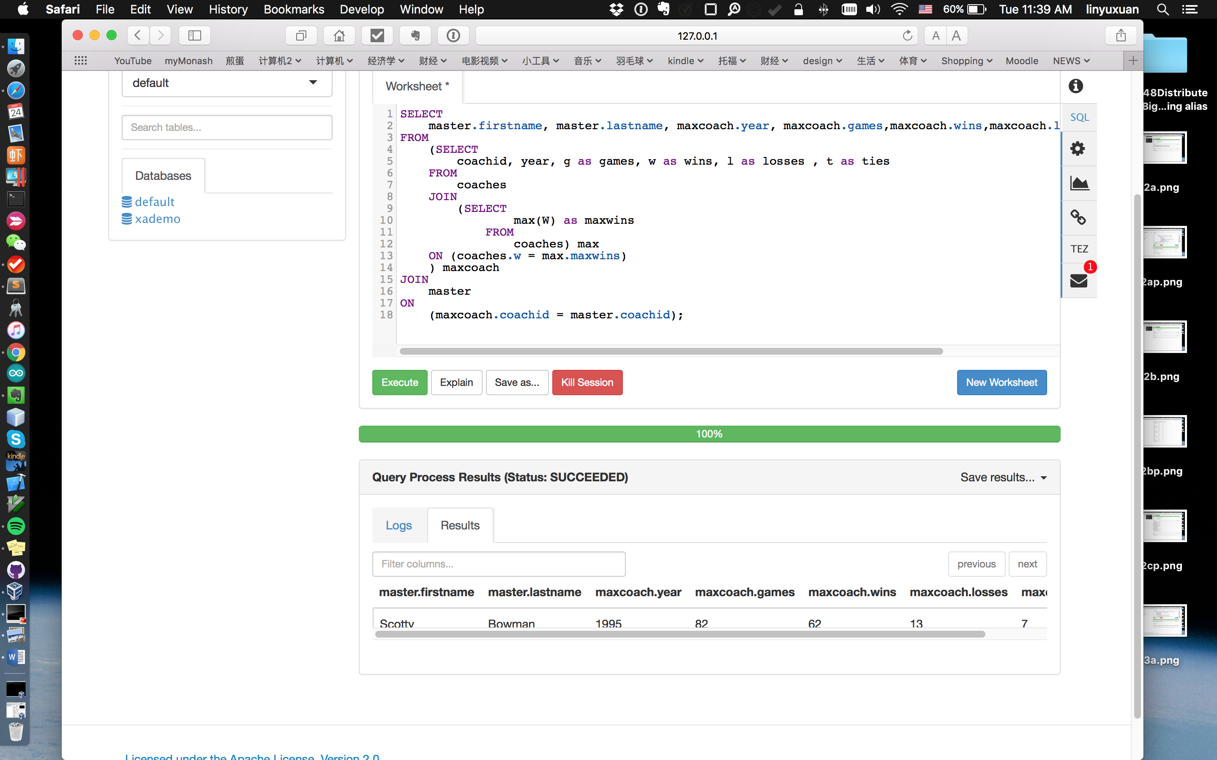
* Pig script:

coaches_raw = LOAD 'coaches'

using org.apache.hive.hcatalog.pig.HCatLoader();

m = LOAD 'master'

using org.apache.hive.hcatalog.pig.HCatLoader();

coaches = FOREACH coaches_raw

GENERATE $0 as coachid, $1 as year, $6 as games, $7 as wins, $8 as lossses, $9 as ties;

ms = FOREACH m GENERATE $1 as coachid, $3 as fname, $4 as lname;

coaches_group = GROUP coaches ALL;

max_wins = FOREACH coaches_group GENERATE MAX(coaches.wins) as maxwins;

max_wins_coach = JOIN coaches by ($3), max_wins by ($0);

final_pre = JOIN ms by ($0) ,max_wins_coach by ($0);

final = FOREACH final_pre GENERATE $1 as fname, $2 as lname,$4,$5,$6,$7,$8;--(Scotty,Bowman,1995,82,62,13,7)

DUMP final;

* Result screenshot:
* 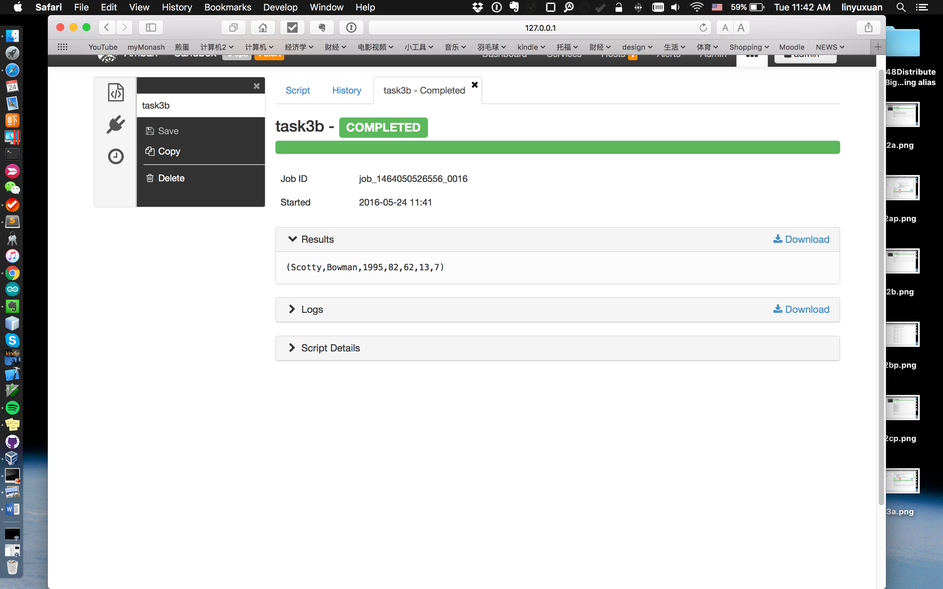
* Time consuming and details:
* Hive:
* 13 secs
* Run with Tez on, maps and reducers.
* Pig:
* 51 secs.
* Run with Tez on, no maps and reduces.
* c) Perform the same query (b) mentioned above but in the results also display the number of awards won by this coach.
* Hive script:

SELECT

awardscounts.num_awards, maxcoachid.fname,maxcoachid.lname,maxcoachid.year, maxcoachid.games, maxcoachid.wins, maxcoachid.losses, maxcoachid.ties

FROM

(SELECT

maxcoach.coachid as coachid, master.firstname as fname, master.lastname as lname, maxcoach.year as year, maxcoach.games as games,maxcoach.wins as wins,maxcoach.losses as losses,maxcoach.ties as ties

FROM

(SELECT

coachid, year, g as games, w as wins, l as losses , t as ties

FROM

coaches

JOIN

(SELECT

max(W) as maxwins

FROM

coaches) max

ON (coaches.w = max.maxwins)

) maxcoach

JOIN

master

ON

(maxcoach.coachid = master.coachid)) maxcoachid

JOIN

(SELECT

count(award) as num_awards,coachid

FROM awardscoaches

GROUP BY (coachid)

) awardscounts

ON (maxcoachid.coachid = awardscounts.coachid);

* Result screenshot:
* 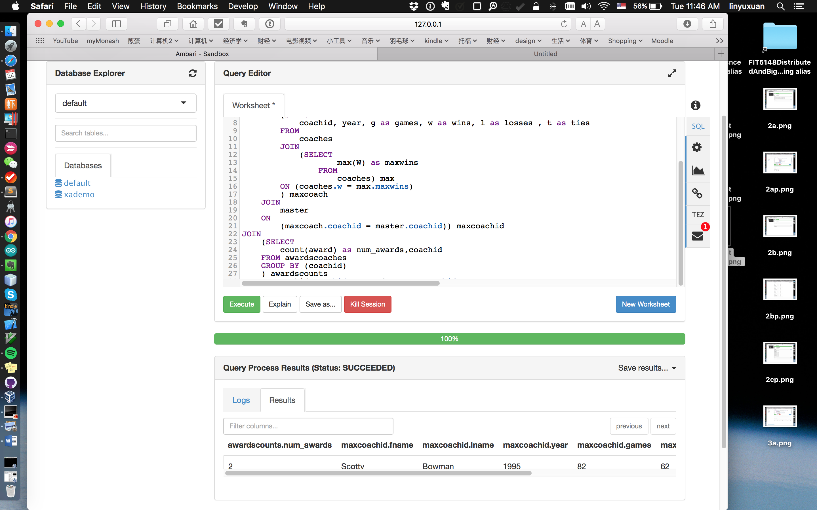
* 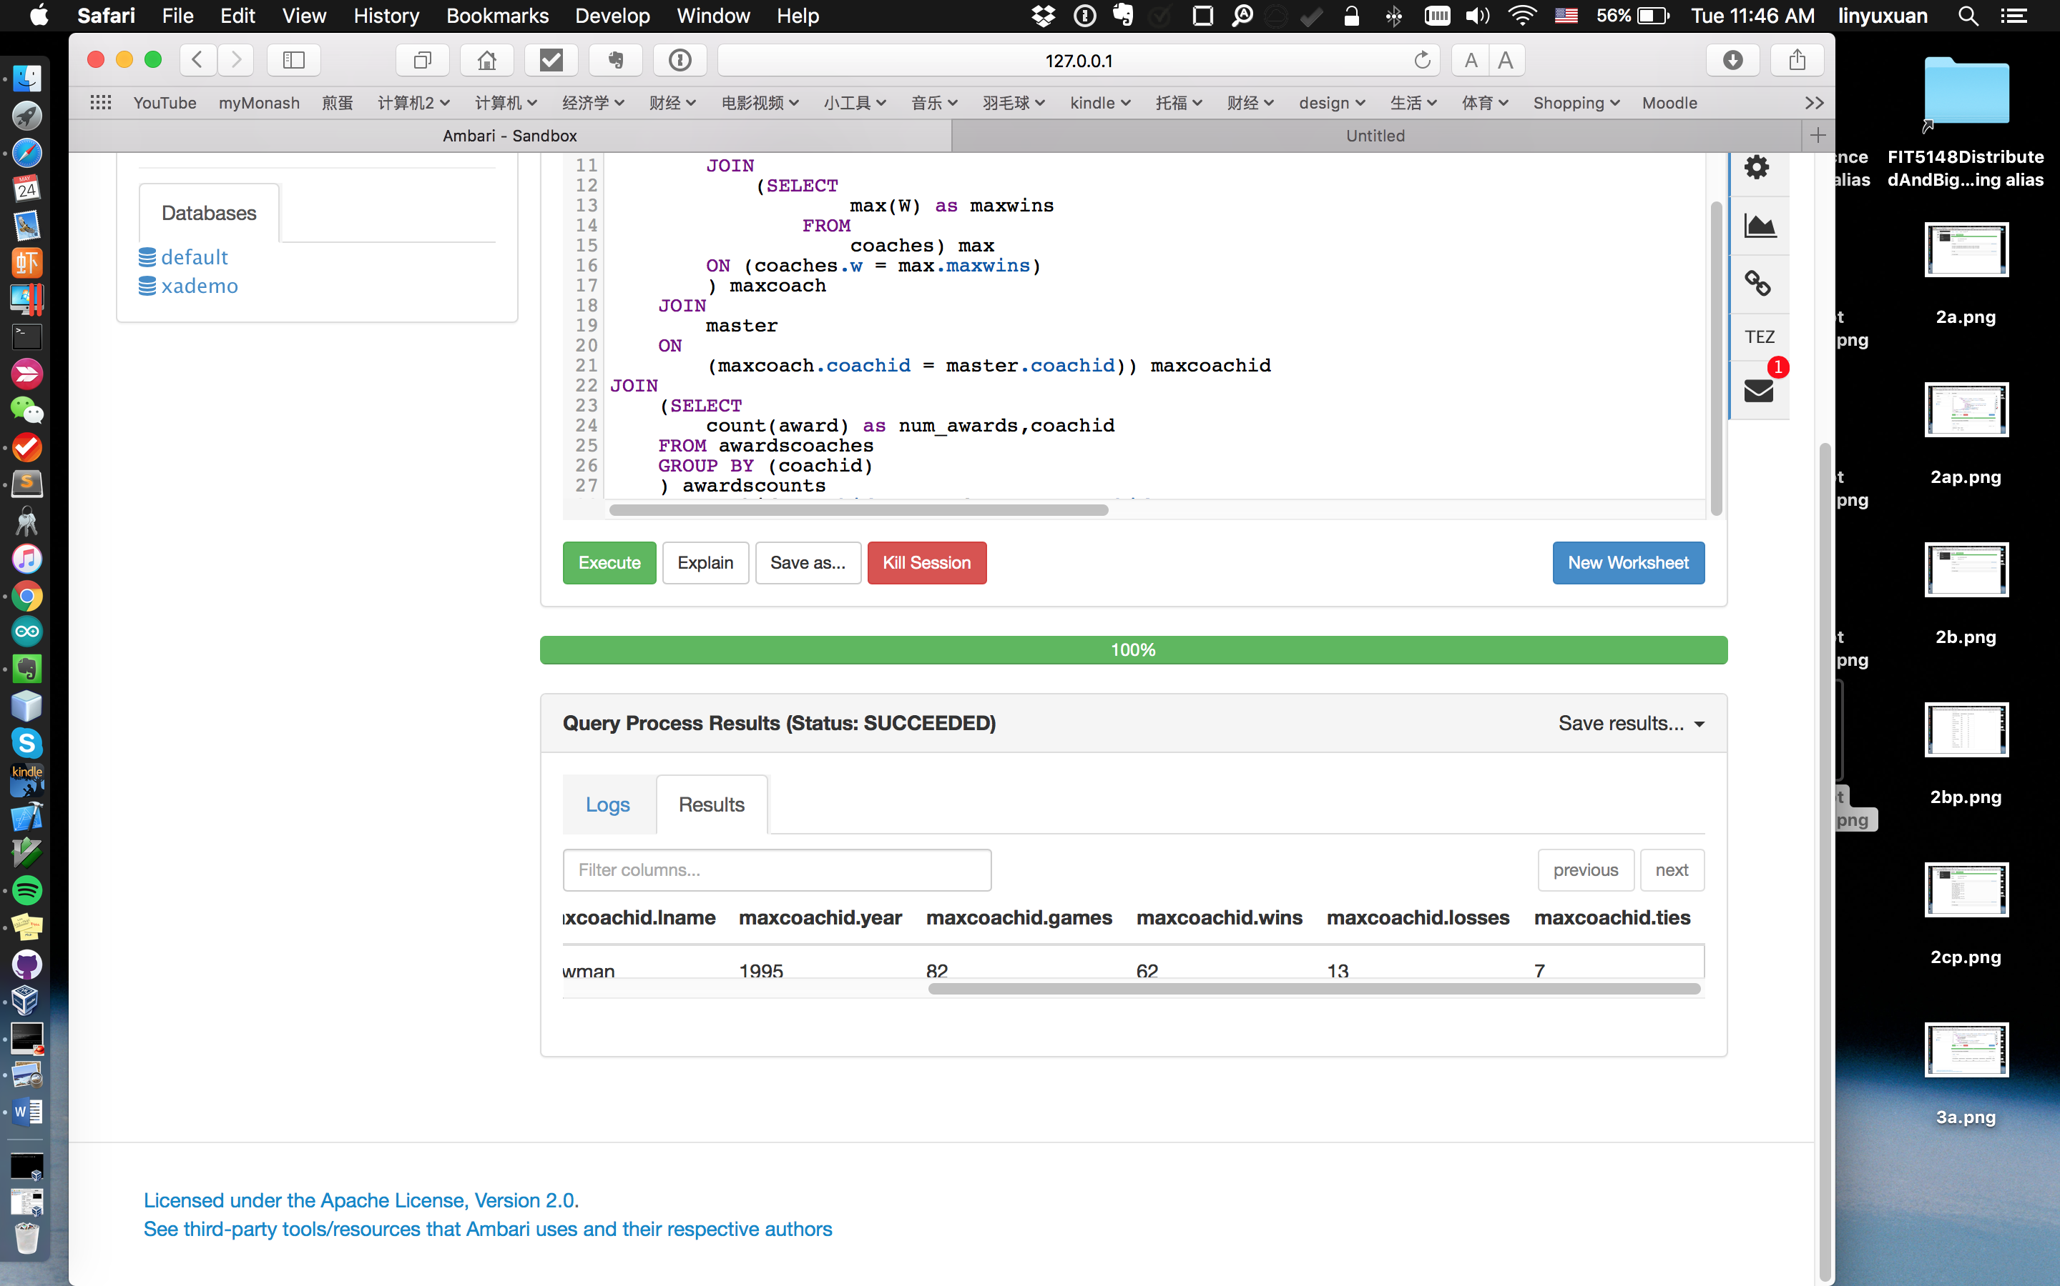
* Pig script:
* --load table
* coaches_raw = LOAD 'coaches'
* using org.apache.hive.hcatalog.pig.HCatLoader();
* m = LOAD 'master'
* using org.apache.hive.hcatalog.pig.HCatLoader();
* --Trim table
* coaches = FOREACH coaches_raw
* GENERATE $0 as coachid, $1 as year, $6 as games, $7 as wins, $8 as lossses, $9 as ties;
* ms = FOREACH m GENERATE $1 as coachid, $3 as fname, $4 as lname;
* --Group to find max wins
* coaches_group = GROUP coaches ALL;
* max_wins = FOREACH coaches_group GENERATE MAX(coaches.wins) as maxwins;
* --Find coach with max wins
* max_wins_coach = JOIN coaches by ($3), max_wins by ($0);
* --Join to find other information about the max wins' coach
* final_pre = JOIN ms by ($0) ,max_wins_coach by ($0);
* maxwinscoah = FOREACH final_pre GENERATE $1 as fname, $2 as lname ,$3,$4,$5,$6,$7,$8;--(Scotty,Bowman,bowmasc01c,1995,82,62,13,7)
* ac_raw = LOAD 'awardscoaches'
* using org.apache.hive.hcatalog.pig.HCatLoader();
* m = LOAD 'master'
* using org.apache.hive.hcatalog.pig.HCatLoader();
* ac = FOREACH ac_raw GENERATE $0 as coachid, $1 as award, $2 as year;
* ms = FOREACH m GENERATE $1 as coachid, $3 as fname, $4 as lname, $19 as byear, $20 as bmon, $21 as bday, $22 as bcountry;
* --group and count awards of coach
* ac_group = GROUP ac by coachid;
* ac_count = FOREACH ac_group GENERATE group as coachid, COUNT(ac) as num_awards;
* --Find the awards of this max wins' coach;
* awards_coach = JOIN ac_count by ($0), maxwinscoah by ($2);--(bowmasc01c,2,Scotty,Bowman,bowmasc01c,1995,82,62,13,7)
* final_awards_coach = FOREACH awards_coach GENERATE $1 as awards, $2 as fname, $3 as lname, $5 as year, $6, $7,$8,$9;
* DUMP final_awards_coach;
* Result screenshot:
* 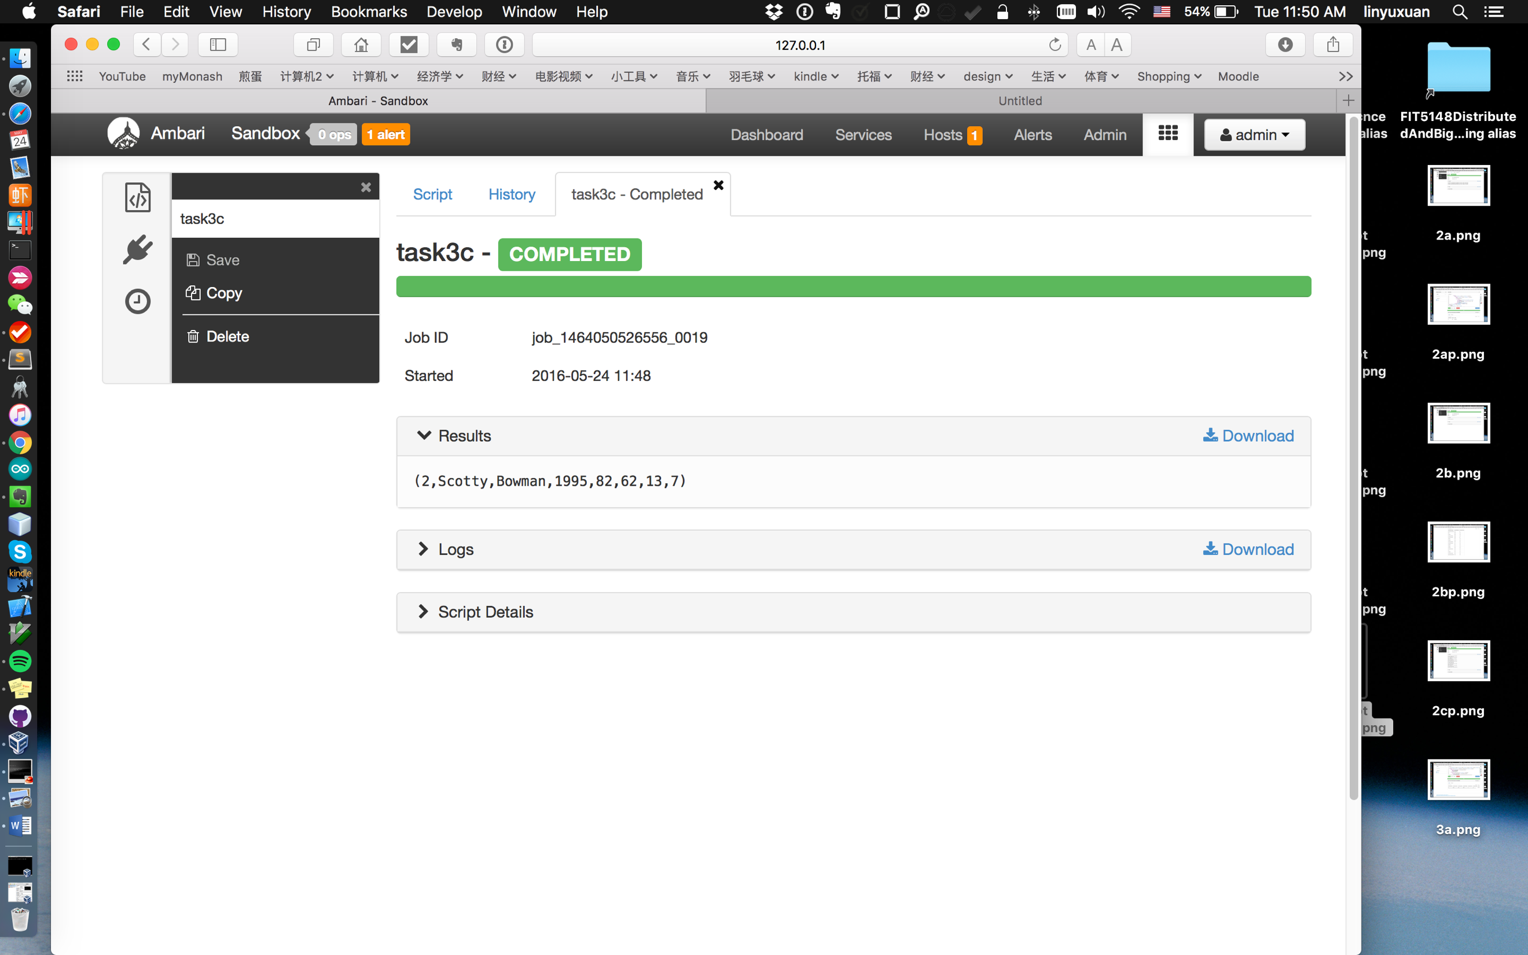
* Time consuming and details:
* Hive:
* 14 secs
* Run with Tez on, maps and reducers.
* Pig:
* 53 secs
* Run with Tez on, no maps and reducers.
* **Task 4 Teams (4 marks):**
* a) Find out the total number of points, goals and assists by each team. In the query results show the following details for all the teams: team name, total number of points, total number goals and total number of assists.
* Hive script:

SELECT spts.tmid, spts.pts, goalsAndAssists.goal, goalsAndAssists.assists

FROM

(SELECT tmid, sum(pts) as pts

FROM

teams

GROUP BY (tmid)

) spts

JOIN

(SELECT

tmid, sum(g) as goal , sum(a) as assists

FROM

scoring

GROUP by (tmid)) goalsAndAssists

ON (spts.tmid = goalsAndAssists.tmid);

* Result screenshot:
* 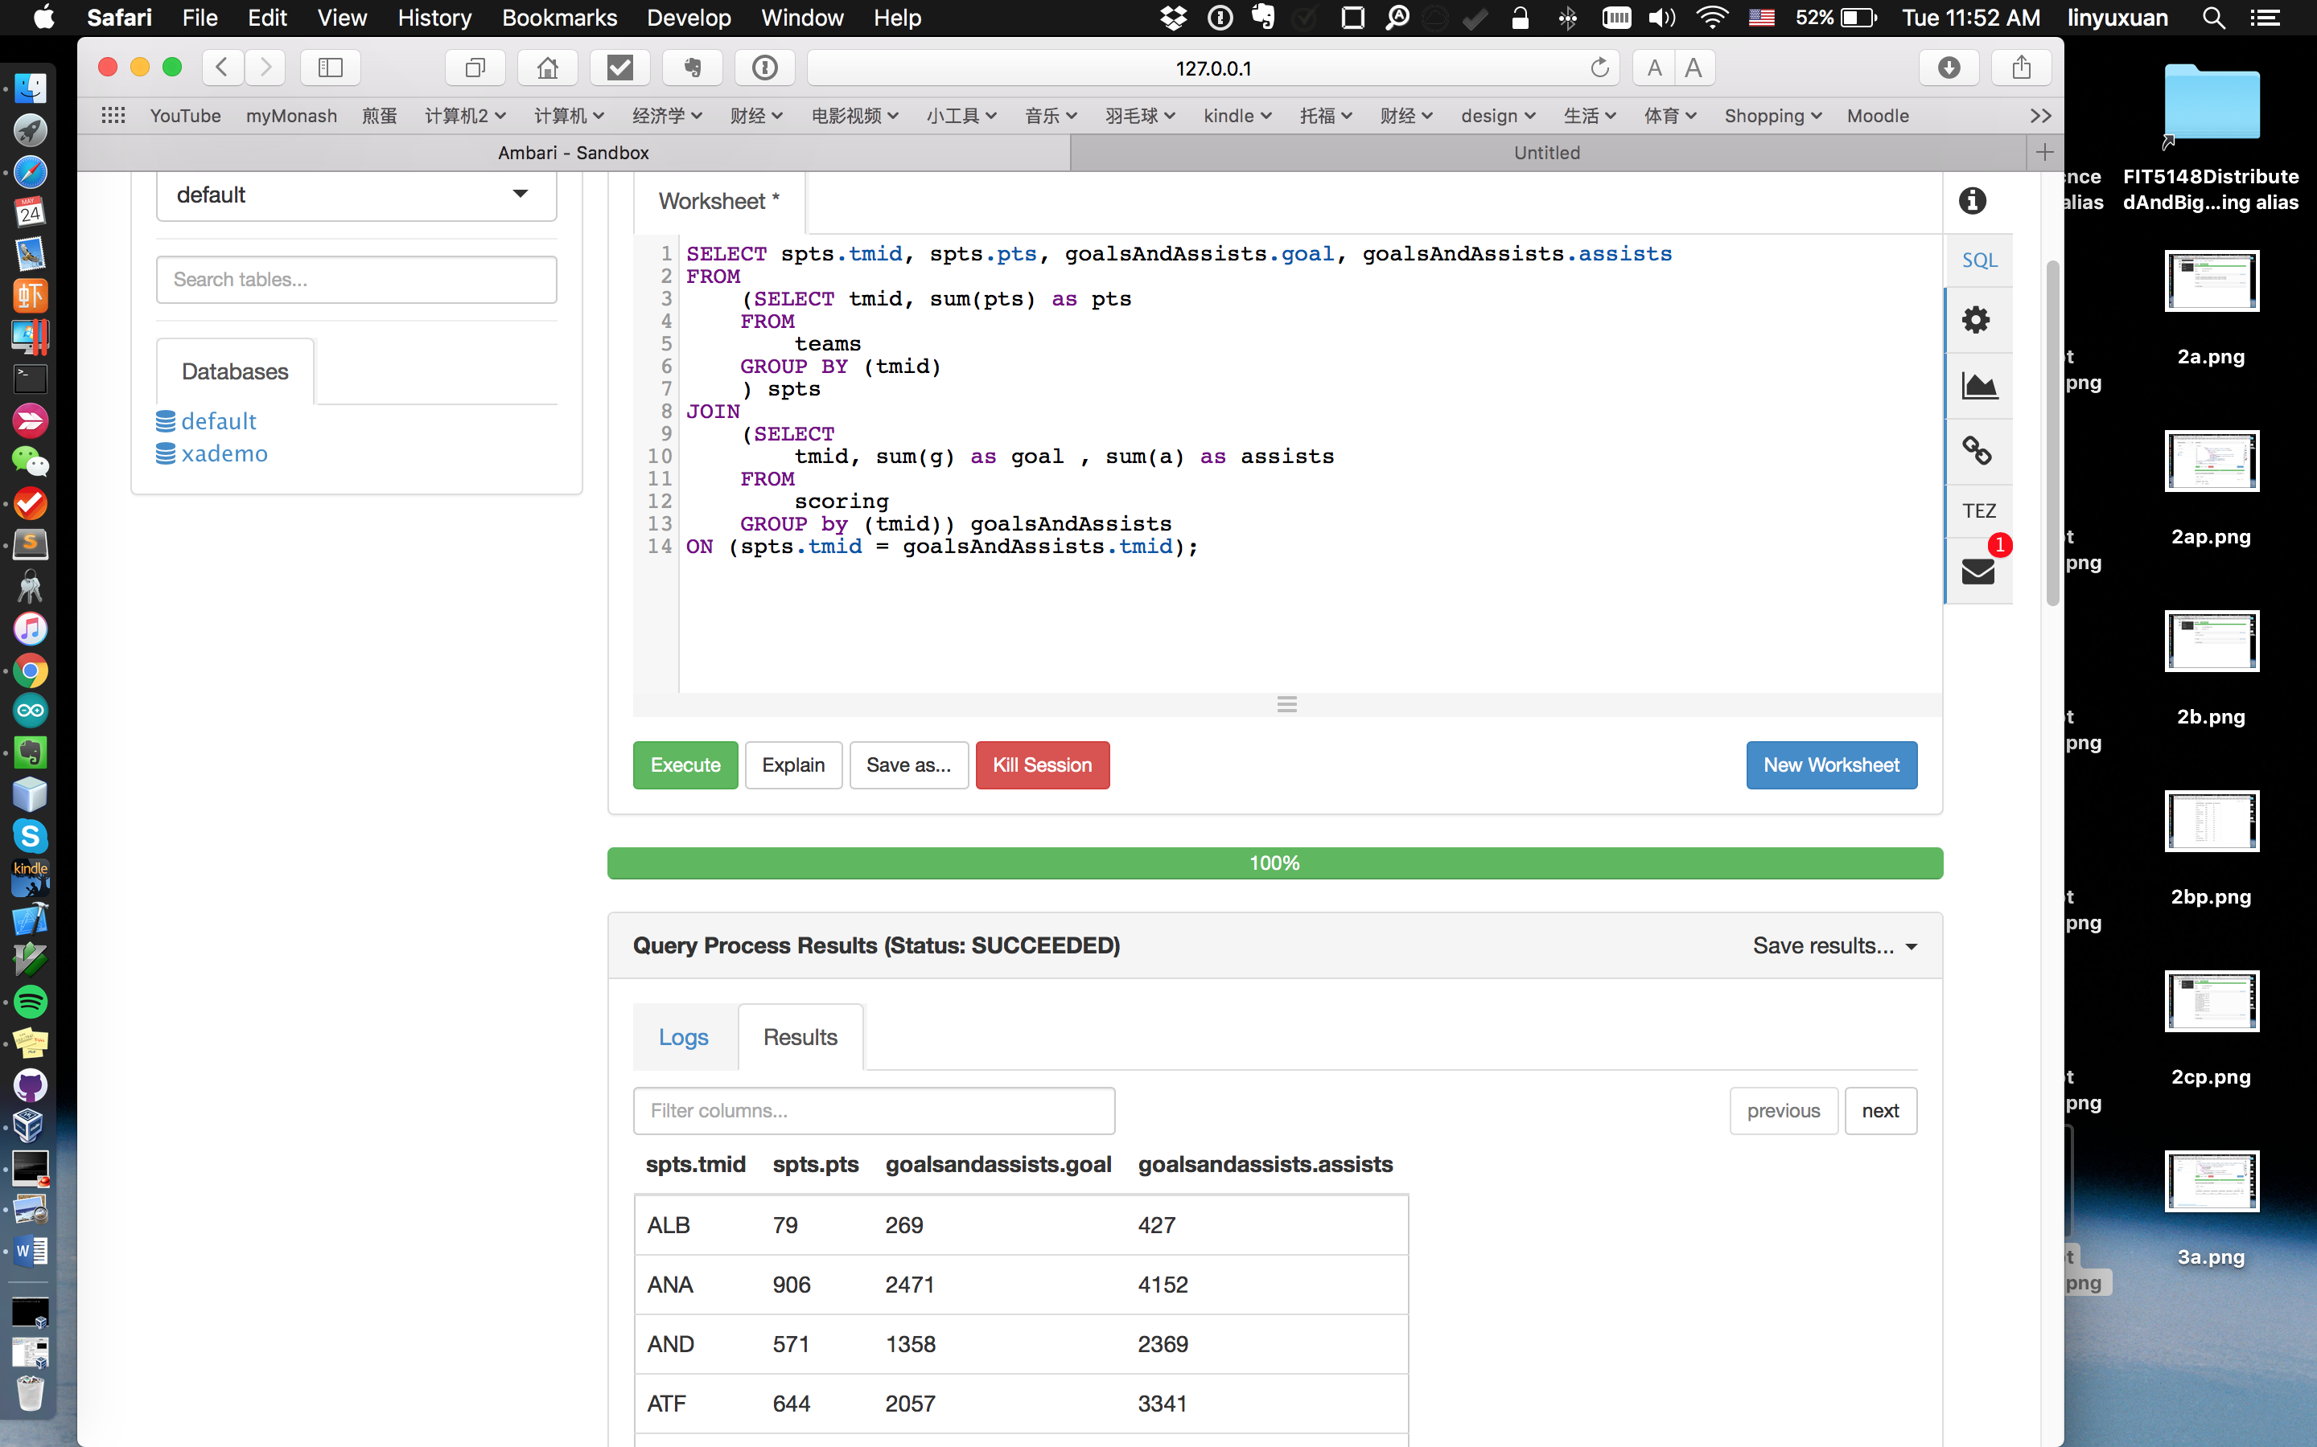
* 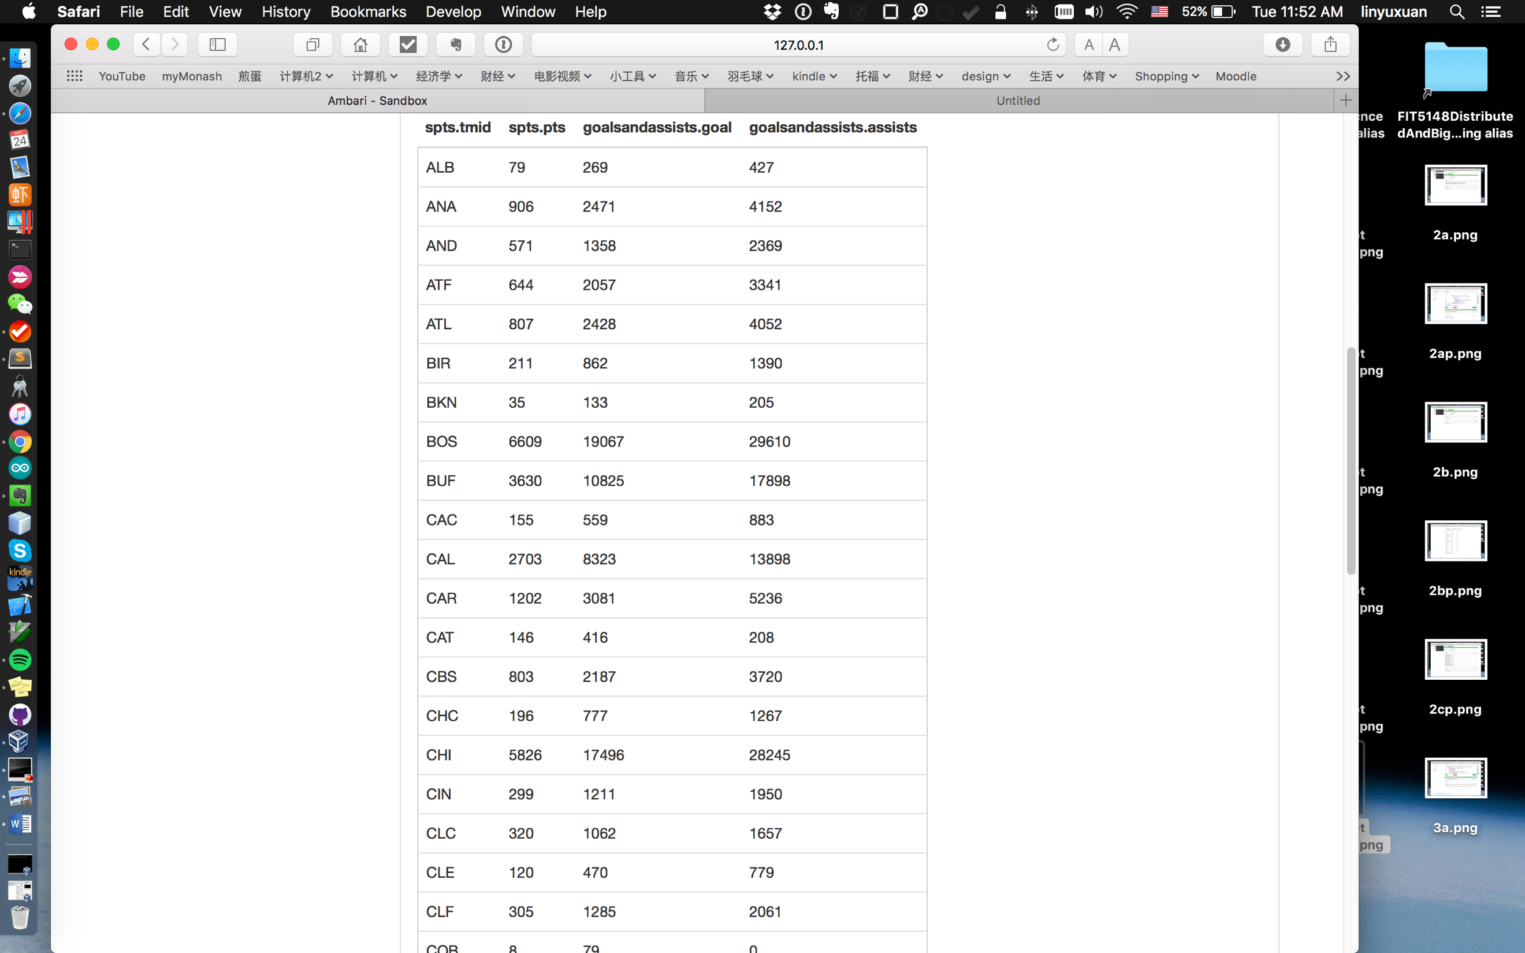
* 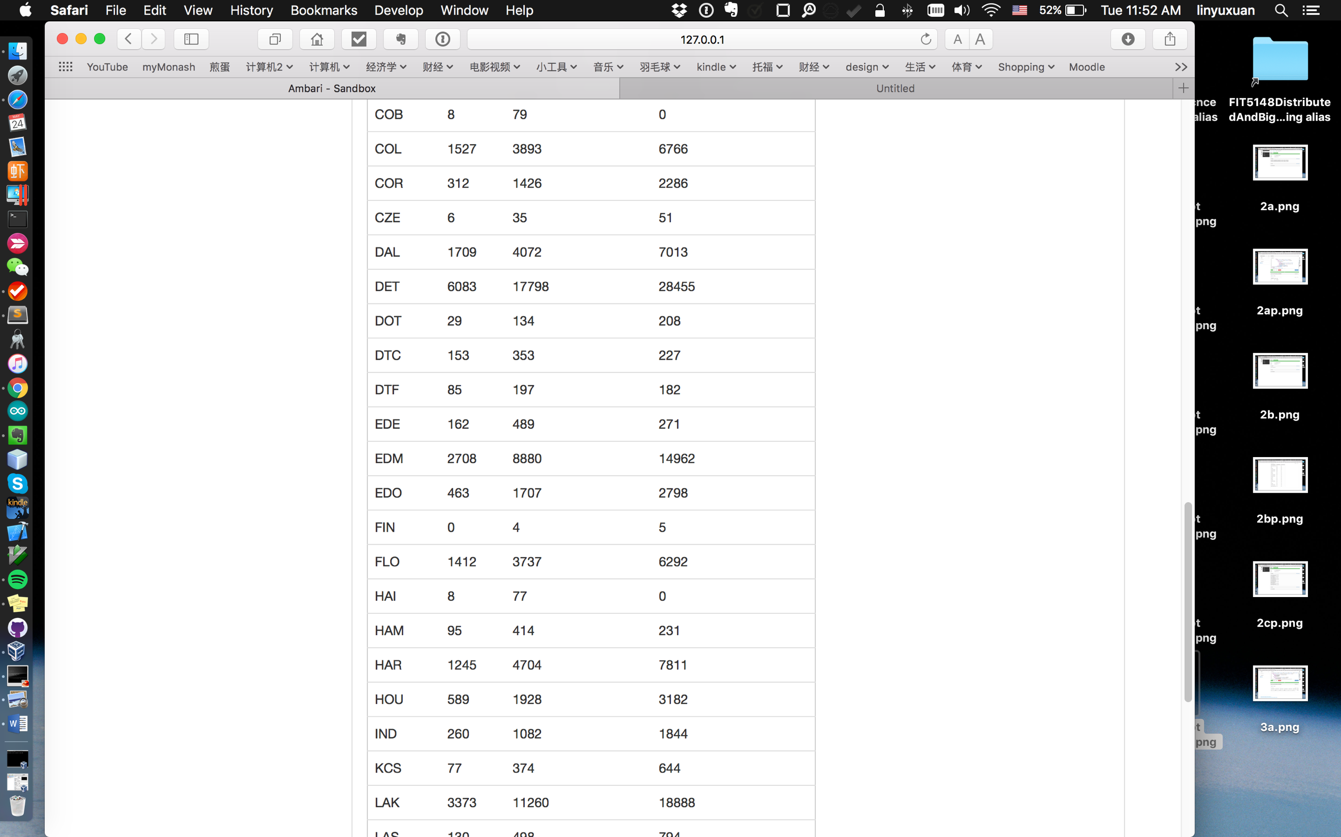
* 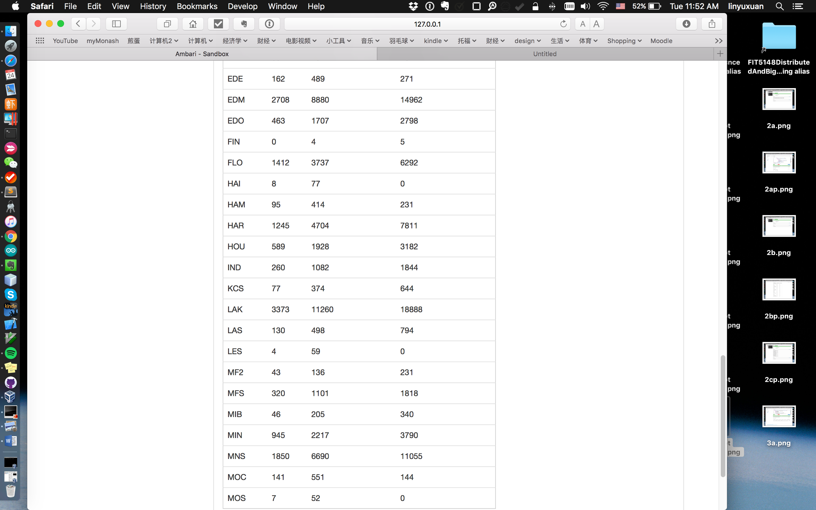
* Pig script:

--load table

teams_raw = LOAD 'teams'

using org.apache.hive.hcatalog.pig.HCatLoader();

scoring_raw = LOAD 'scoring'

using org.apache.hive.hcatalog.pig.HCatLoader();

--trim table

teams = FOREACH teams_raw GENERATE $2 as tmid, $13 as points, $18 as teamname;

allteamsid = FOREACH teams GENERATE $0 as tmid;

teamsid = DISTINCT allteamsid;

-- DUMP A_unique;

scoring = FOREACH scoring_raw GENERATE $3 as tmid, $7 as goals, $8 as assists;

--aggregate points by tmid from table team

teams_gb_tmid = GROUP teams by tmid;

teamSumPoints = FOREACH teams_gb_tmid GENERATE group as tmid, SUM(teams.points) as sumpoints;--(ANA,427)

--aggregate assists by tmid from table scoring

scoring_bg_tmid = GROUP scoring by tmid;

assistsSum_scoring = FOREACH scoring_bg_tmid GENERATE group as tmid, SUM(scoring.assists) as sumassists;--(ANA,4152)

-- DUMP assistsSum_scoring;

--aggregate goals by tmid from table scoring

goalsSum_scoring = FOREACH scoring_bg_tmid GENERATE group as tmid, SUM(scoring.goals) as sumgoals;--(ANA,2471)

final_pre = JOIN teamsid by ($0), teamSumPoints by ($0), assistsSum_scoring by ($0), goalsSum_scoring by ($0);--(VMR,VMR,34,VMR,59,VMR,155)

final = FOREACH final_pre GENERATE $0, $2, $4, $6;

DUMP final;

Result screenshots:

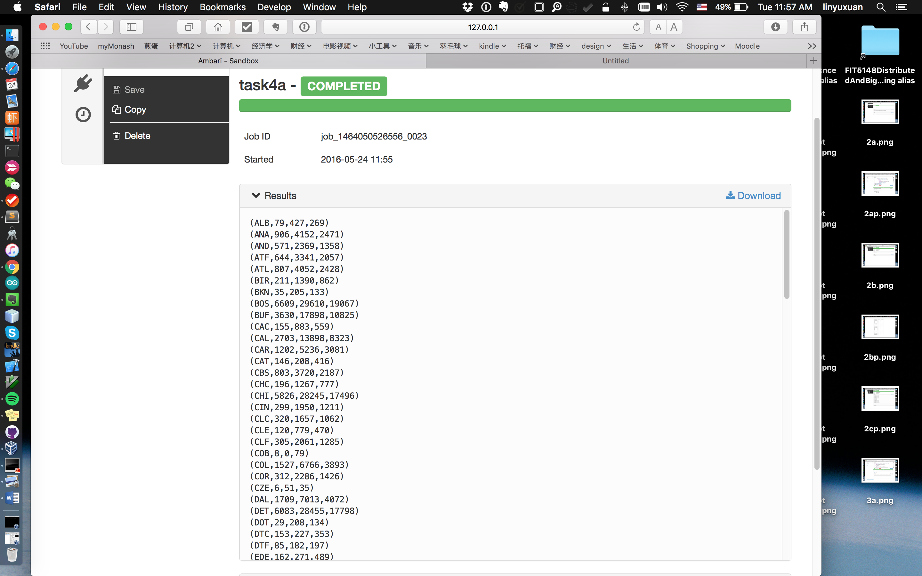

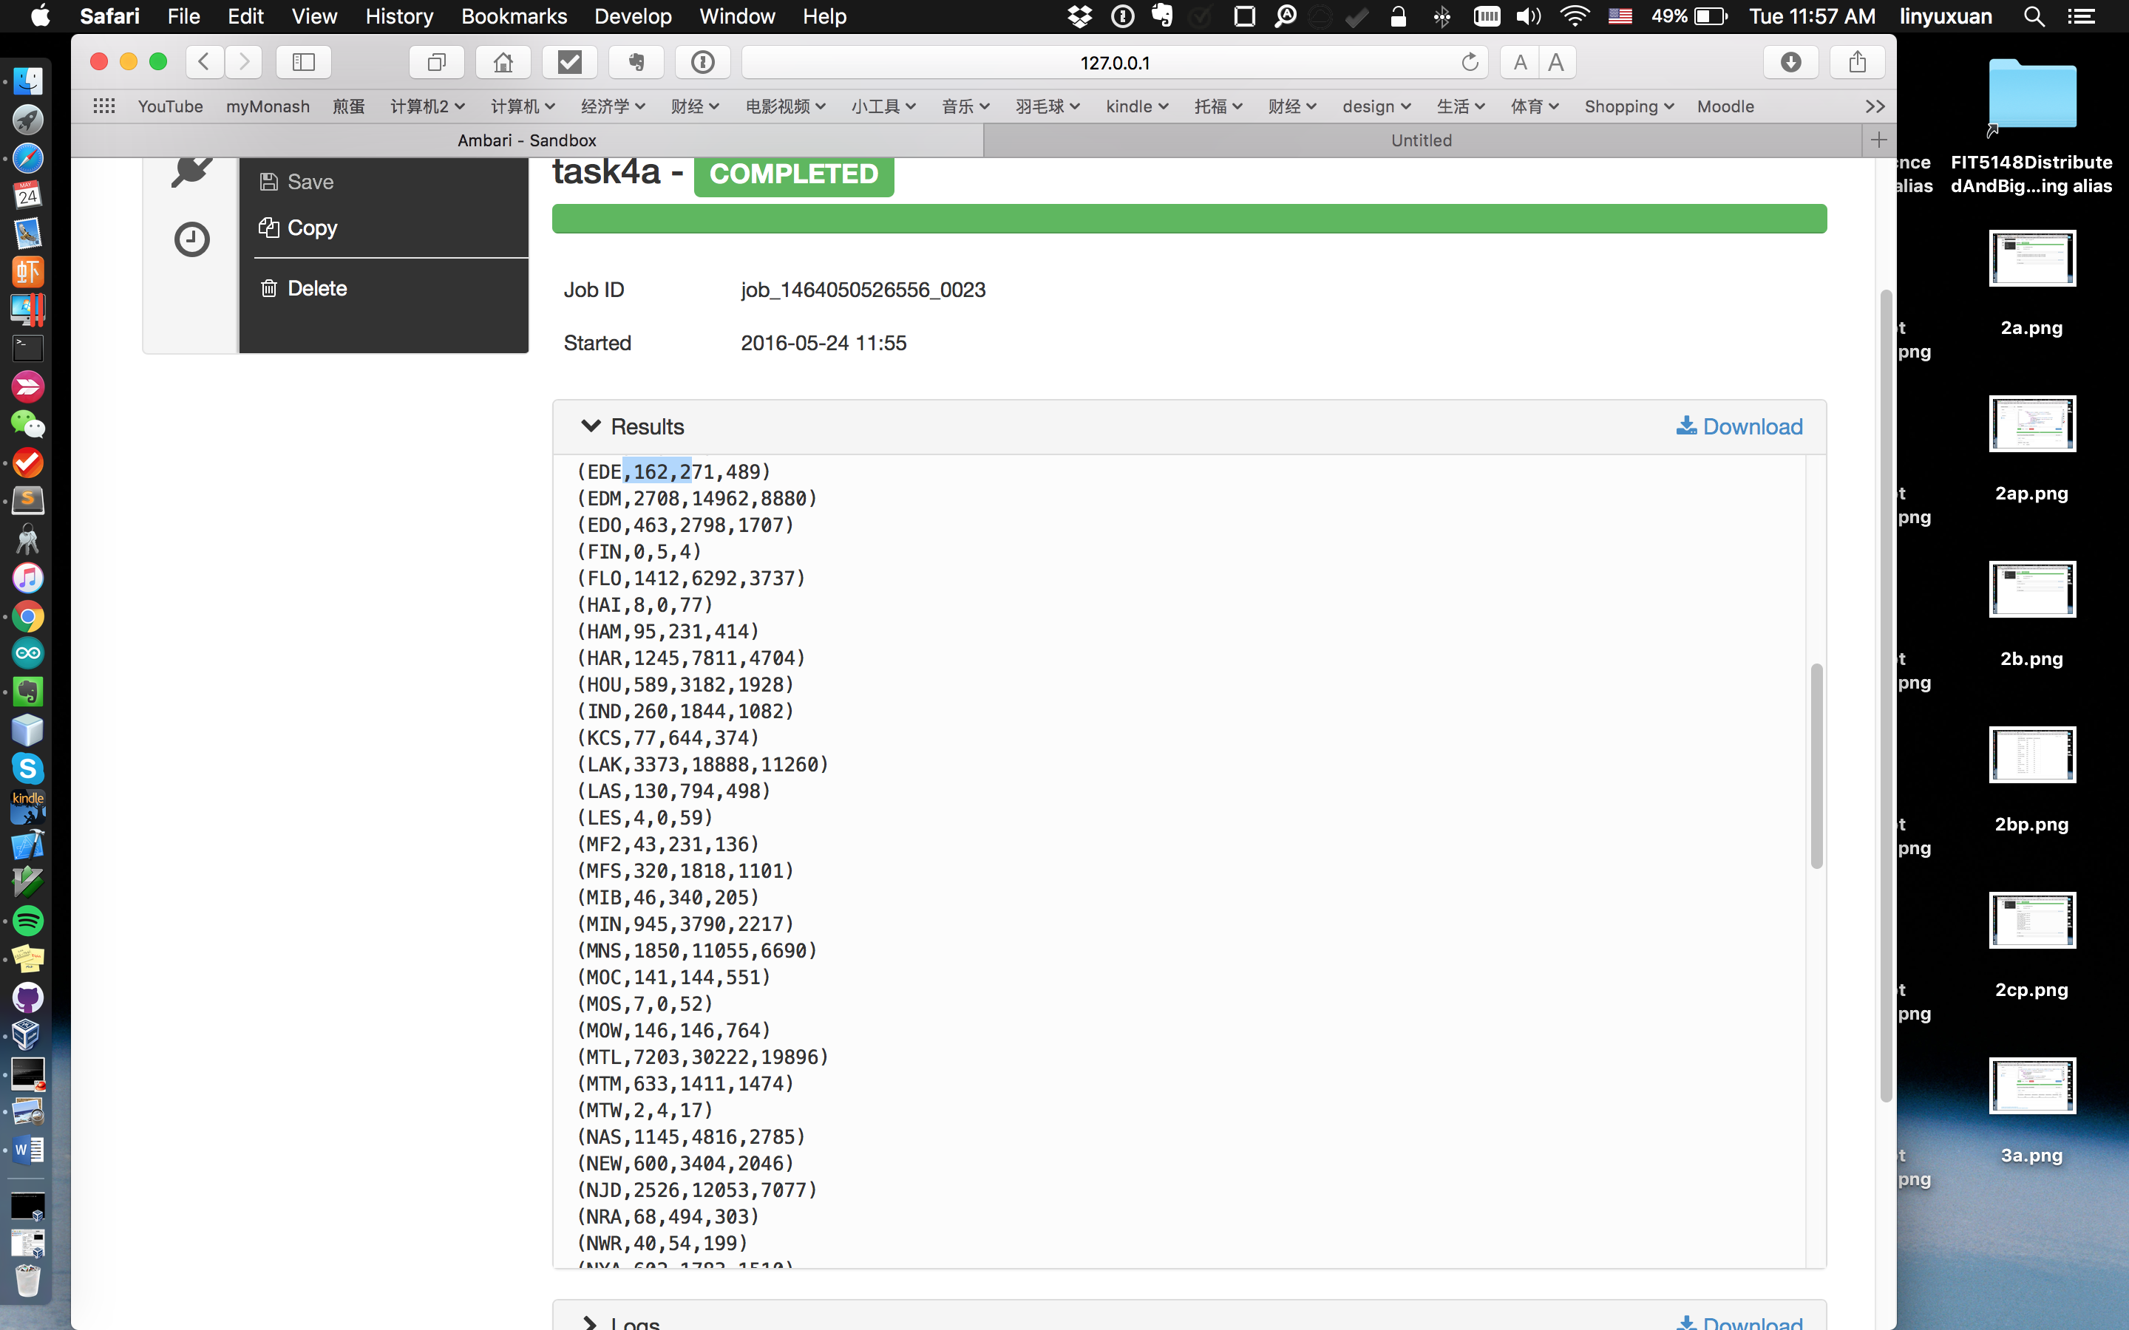

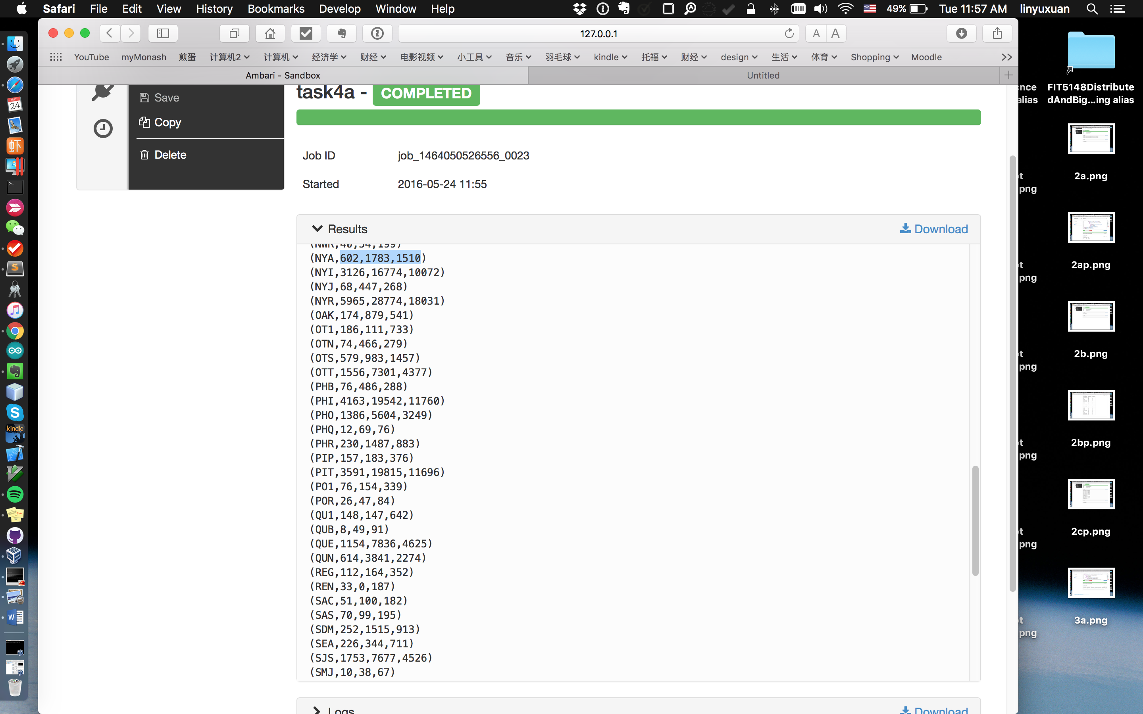

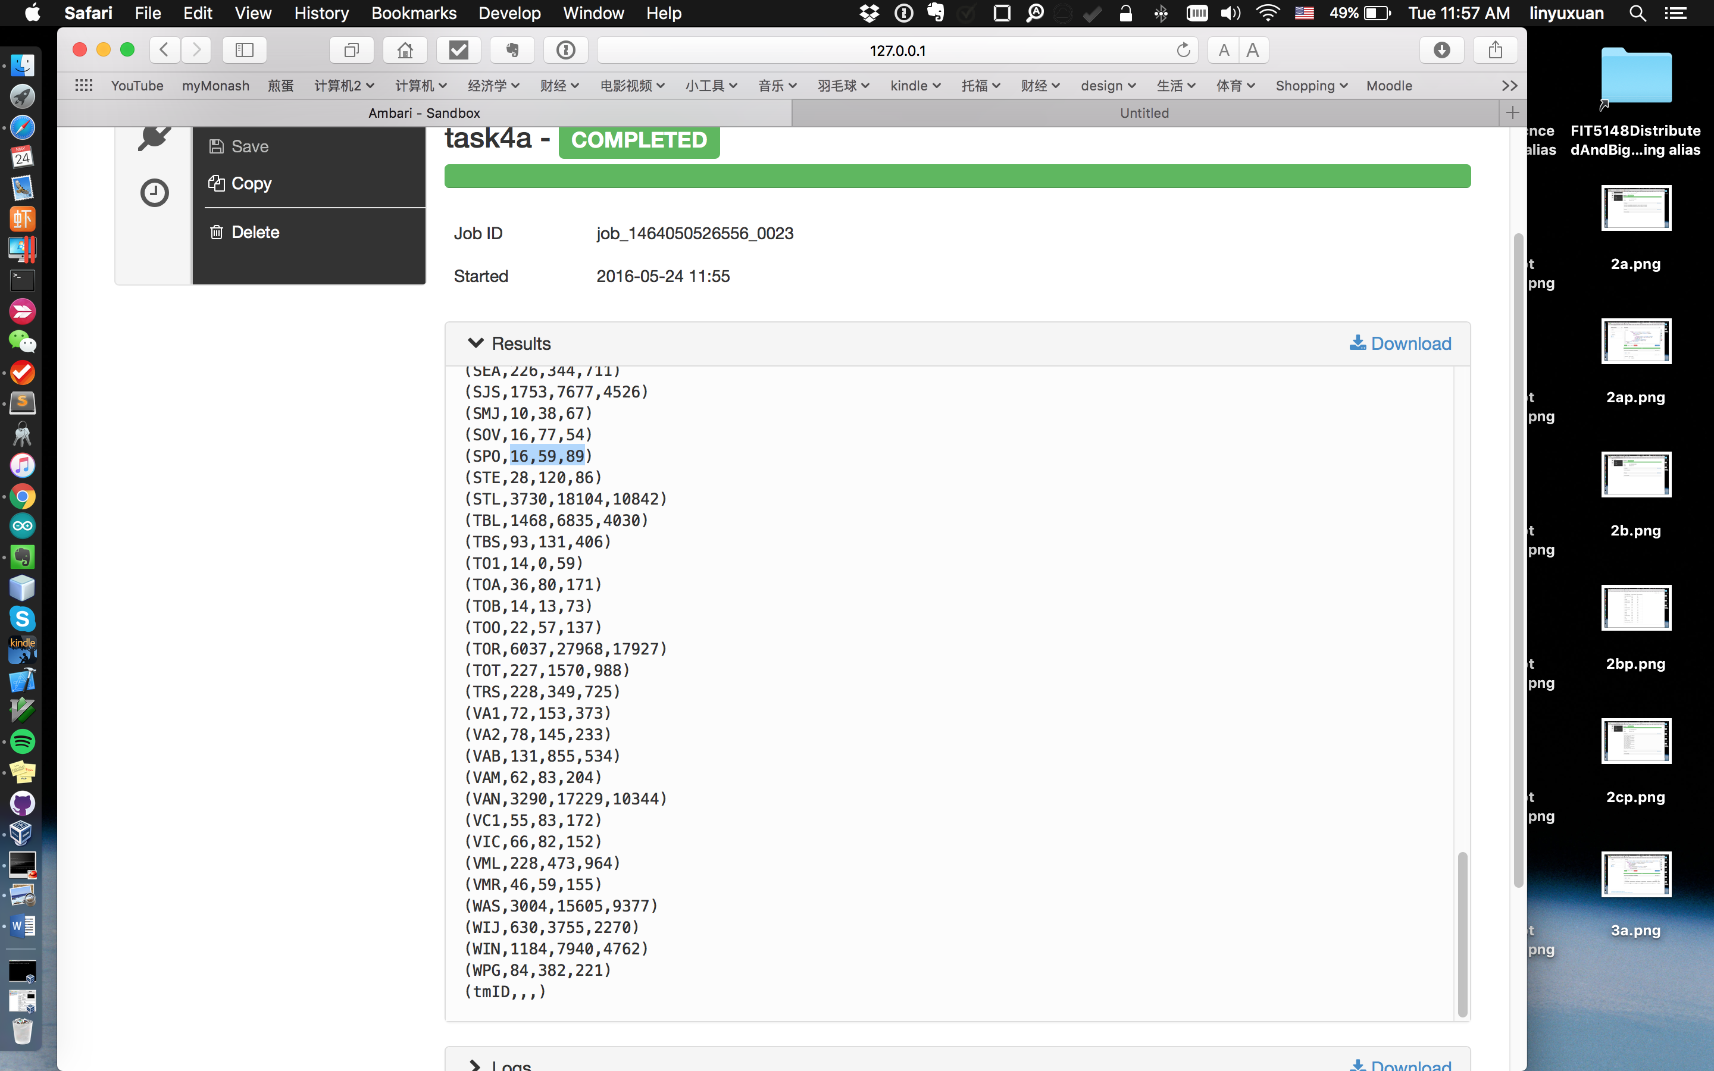

* Time consuming and details:
* Hive:
* 12 secs
* Run with Tez on, maps and reducers.
* Pig:
* 51 secs
* Run with Tez on, no maps and reducers.
* b) Find out for each team which player had scored the highest total number of points. In the query results show the following details: team name, player first and last name, year, number of points, goals and assists.
* Hive script:

SELECT

teams2.name,base2.firstname, base2.lastname, base2.year,base2.points, base2.goal, base2.assist

FROM

(SELECT

m.firstname, m.lastname,base.pid, base.tid, base.points, base.goal, base.assist, base.year as year

FROM

master m

JOIN

(SELECT

s.playerid as pid, s.tmid as tid, s.pts as points, s.g as goal, s.a as assist, s.year

FROM

scoring s

JOIN

(SELECT tmid, MAX(pts) as pts

FROM

scoring

GROUP by (tmid)) maxpts

ON (s.tmid = maxpts.tmid and s.pts = maxpts.pts)) base

ON(m.playerid = base.pid)

) base2

JOIN

(SELECT

DISTINCT tmid, name

from teams) teams2

ON (base2.tid = teams2.tmid)

;

* Result screenshot:

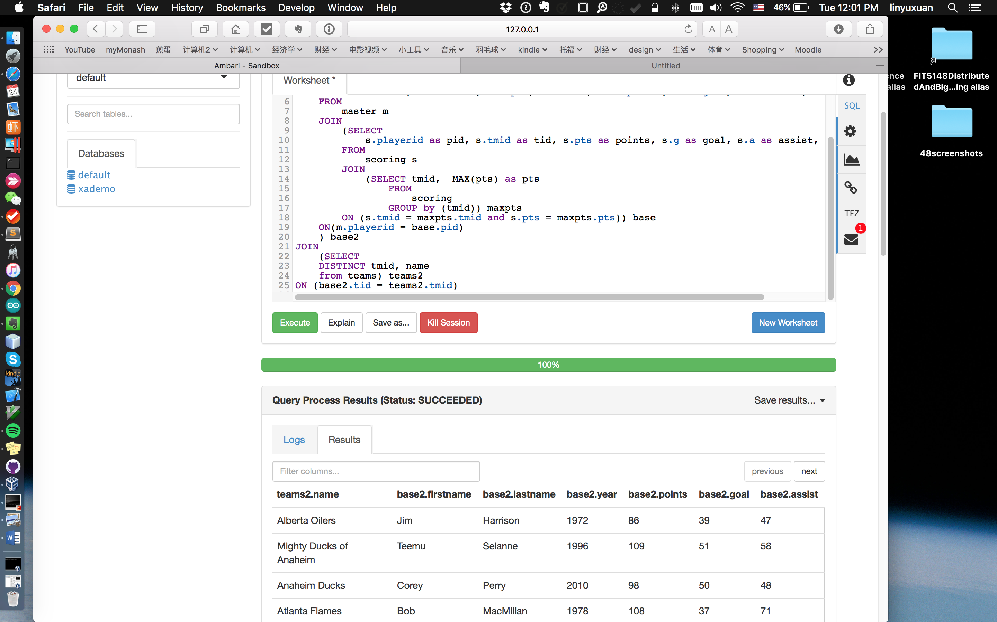

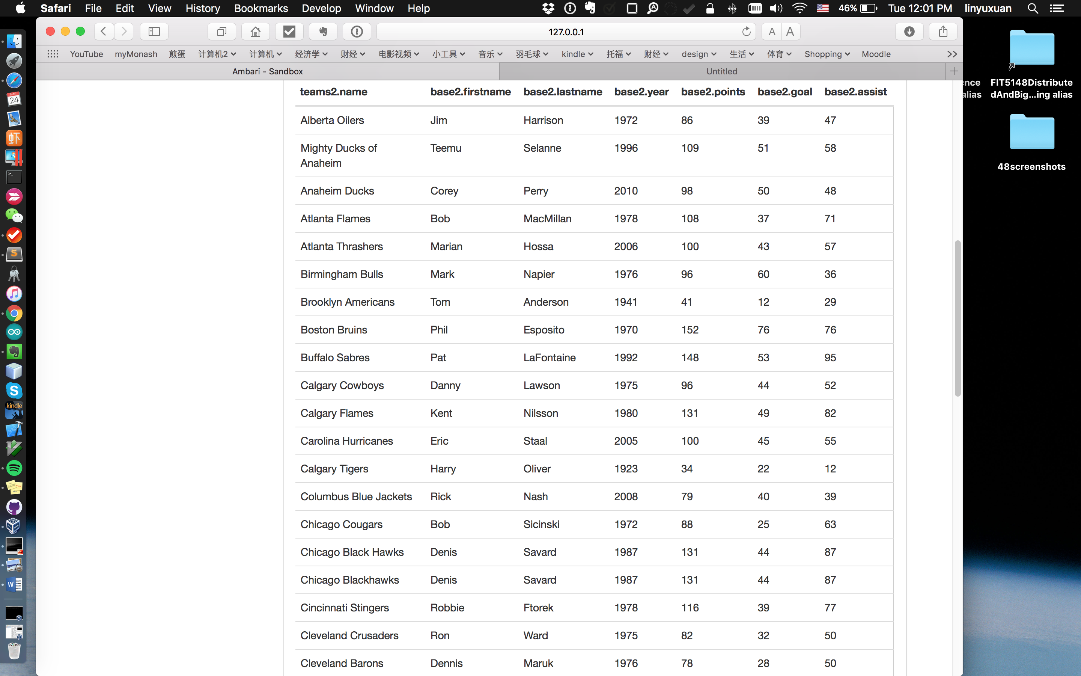

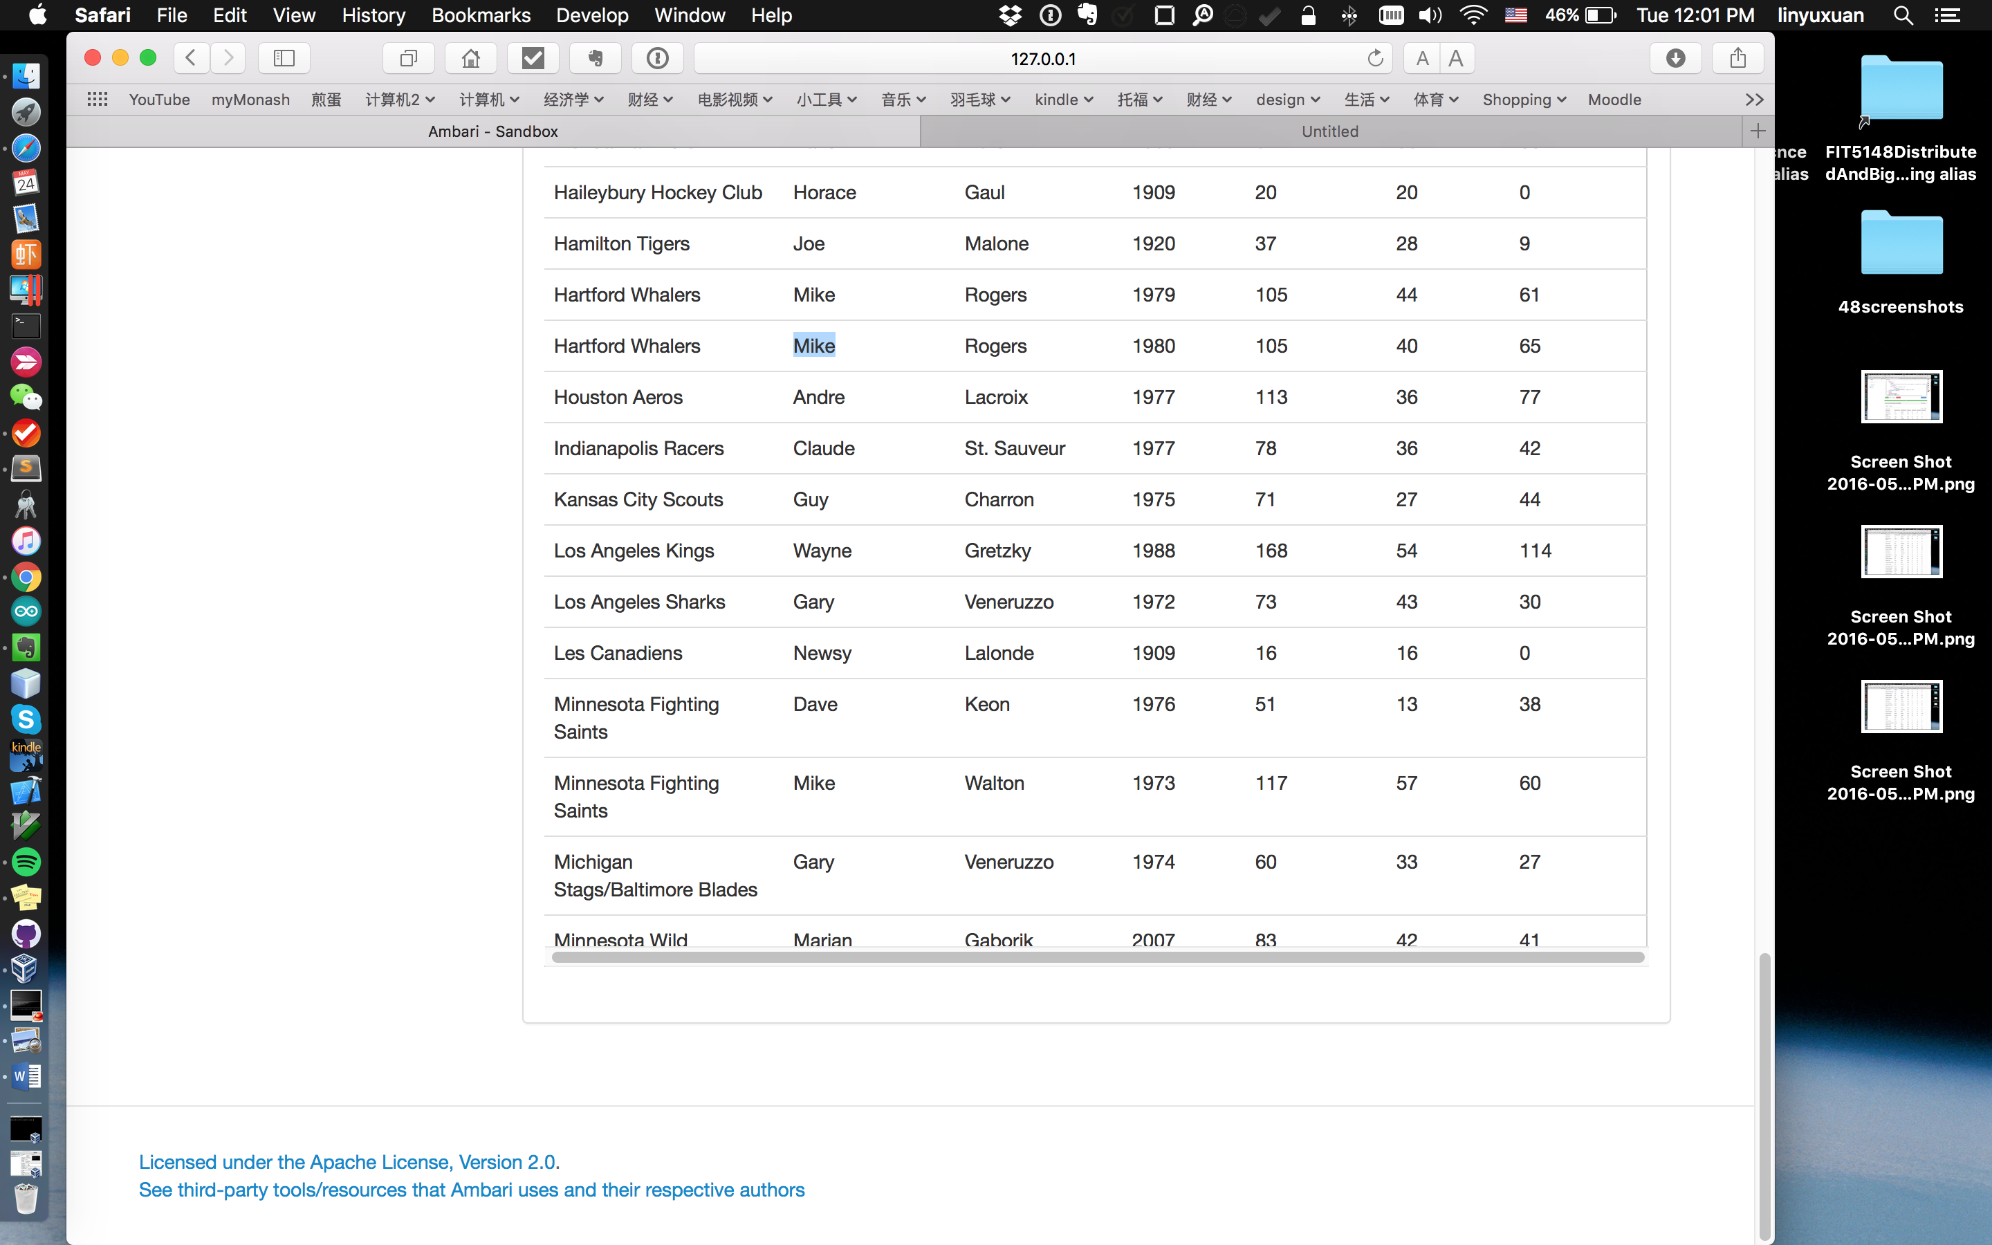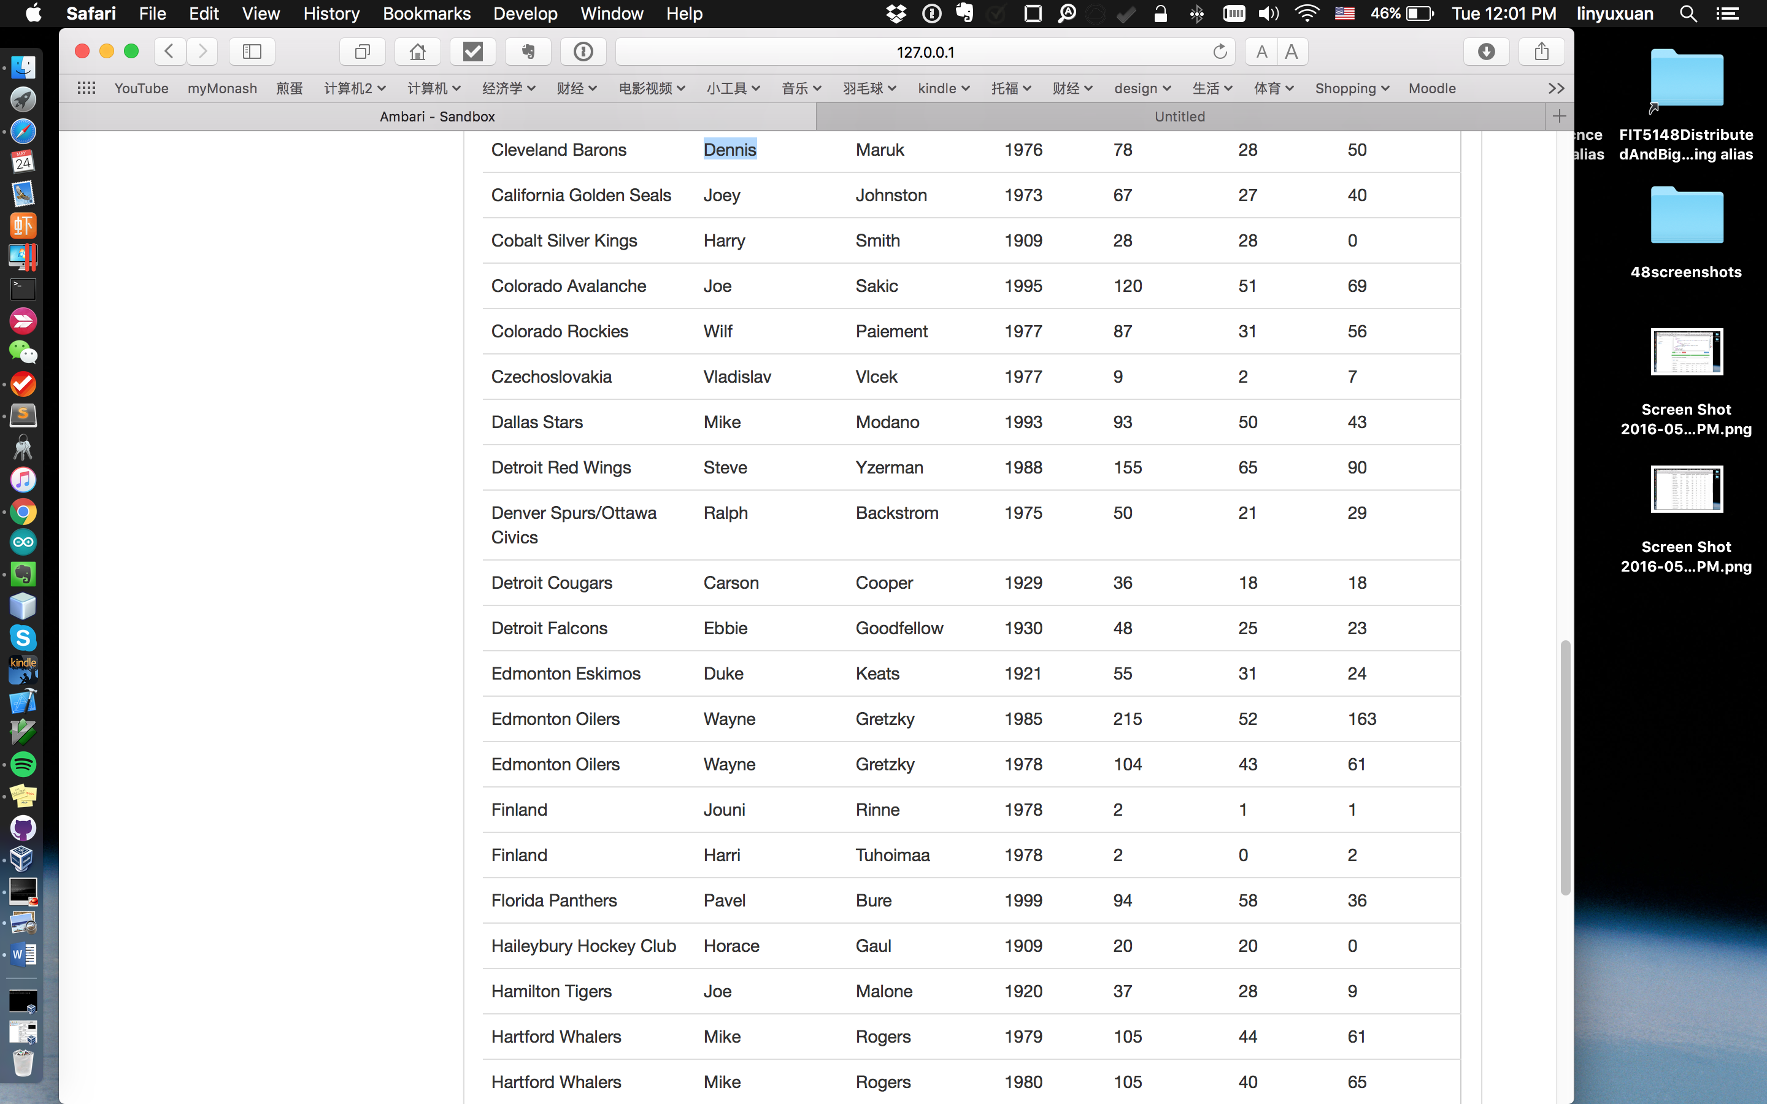

* Pig script:
* --load table
* teams_raw = LOAD 'teams'
* using org.apache.hive.hcatalog.pig.HCatLoader();
* scoring_raw = LOAD 'scoring'
* using org.apache.hive.hcatalog.pig.HCatLoader();
* m = LOAD 'master'
* using org.apache.hive.hcatalog.pig.HCatLoader();
* --trim table
* teams = FOREACH teams_raw GENERATE $2 as tmid, $13 as points, $18 as teamname;
* allteamsid = FOREACH teams GENERATE $0 as tmid;
* teamsid = DISTINCT allteamsid;
* teamsName_pre = FOREACH teams GENERATE $0 as tmid, $2 as teamname;
* teamsName = DISTINCT teamsName_pre;
* master = FOREACH m GENERATE $0 as playerid, $3 as fname, $4 as lname;
* -- DUMP A_unique;
* scoring = FOREACH scoring_raw GENERATE $3 as tmid, $7 as goals, $8 as assists;
* --aggregate points by tmid from table team
* teams_gb_tmid = GROUP teams by tmid;
* teamSumPoints = FOREACH teams_gb_tmid GENERATE group as tmid, SUM(teams.points) as sumpoints;--(ANA,427)
* --aggregate assists by tmid from table scoring
* scoring_bg_tmid = GROUP scoring by tmid;
* assistsSum_scoring = FOREACH scoring_bg_tmid GENERATE group as tmid, SUM(scoring.assists) as sumassists;--(ANA,4152)
* -- DUMP assistsSum_scoring;
* --aggregate goals by tmid from table scoring
* goalsSum_scoring = FOREACH scoring_bg_tmid GENERATE group as tmid, SUM(scoring.goals) as sumgoals;--(ANA,2471)
* final_pre = JOIN teamsid by ($0), teamSumPoints by ($0), assistsSum_scoring by ($0), goalsSum_scoring by ($0);--(VMR,VMR,34,VMR,59,VMR,155)
* finalTeams = FOREACH final_pre GENERATE $0, $2, $4, $6;--(VMR,34,59,155)
* --Trim table
* scoring2 = FOREACH scoring_raw GENERATE $0 as playerid, $3 as tmid , $9 as pts, $1 as year, $7 as goals,$8 as assists;
* teams2 = FOREACH teams_raw GENERATE $2 as tmid, $18 as teamname;
* --Group by tmid
* scoring_tm = GROUP scoring2 by (tmid);
* scoring_max = FOREACH scoring_tm GENERATE group as tmid, MAX(scoring2.pts) as pts;
* x = JOIN scoring_max by ($0, $1), scoring2 by ($1, $2);--(ALB,86,harriji01,ALB,86,1972,39,47)
* m = FOREACH x GENERATE $0 as tmid, $1 as pts, $2 as plyarid, $5 as year, $6 as G, $7 as A;--(ALB,86,harriji01,1972,39,47)
* --JOIN teams
* m_tn = JOIN m by ($0), teamsName by ($0);--(DOT,50,backsra01,1975,21,29,DOT,Denver Spurs/Ottawa Civics)
* -- DUMP m_tn;
* m_xx = FOREACH m_tn GENERATE $0 as tmid, $1 as pts, $2 as pid, $3 as year, $4 as G, $5 as A, $7 as tname;----(DOT,50,backsra01,1975,21,29,Denver Spurs/Ottawa Civics)
* --and master
* final2_pre= JOIN m_xx by ($2), master by ($0);--(TRS,46,dyeba01,1924,38,8,Toronto St. Patricks,dyeba01,Babe,Dye)
* final = FOREACH final2_pre GENERATE $6 as teamname,$8 as fname, $9 as lname, $3 as year,$1 as pts, $4 as G, $5 as A;
* DUMP final;
* Result screenshot:
* 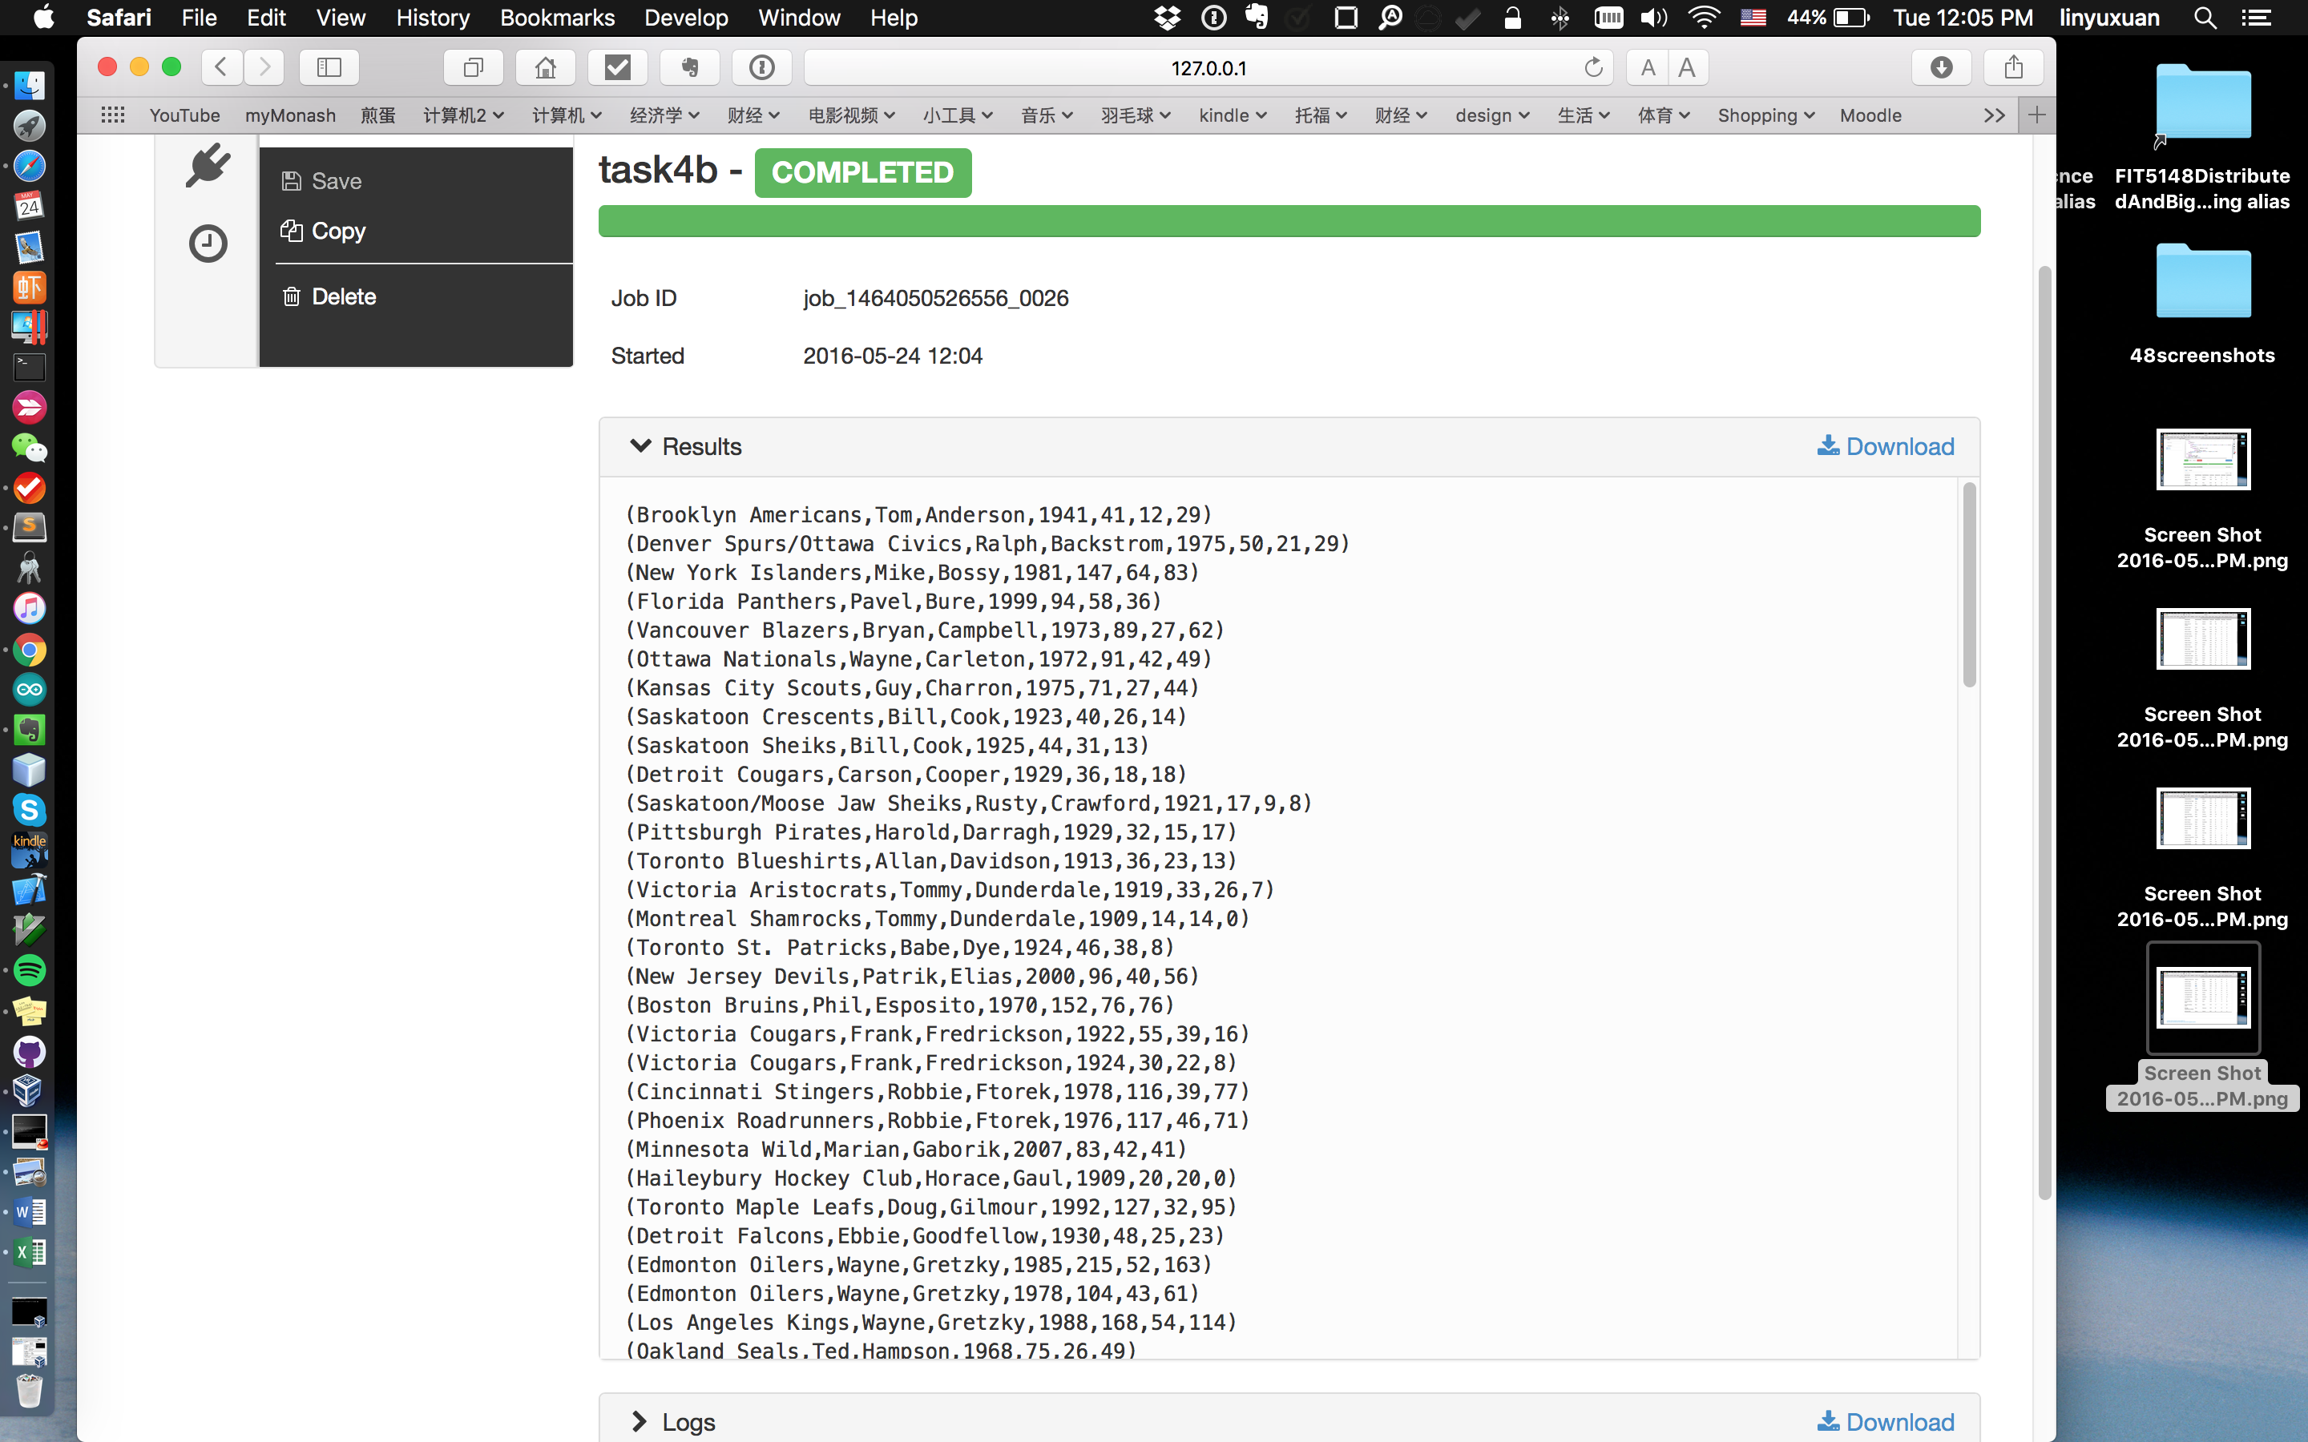
* 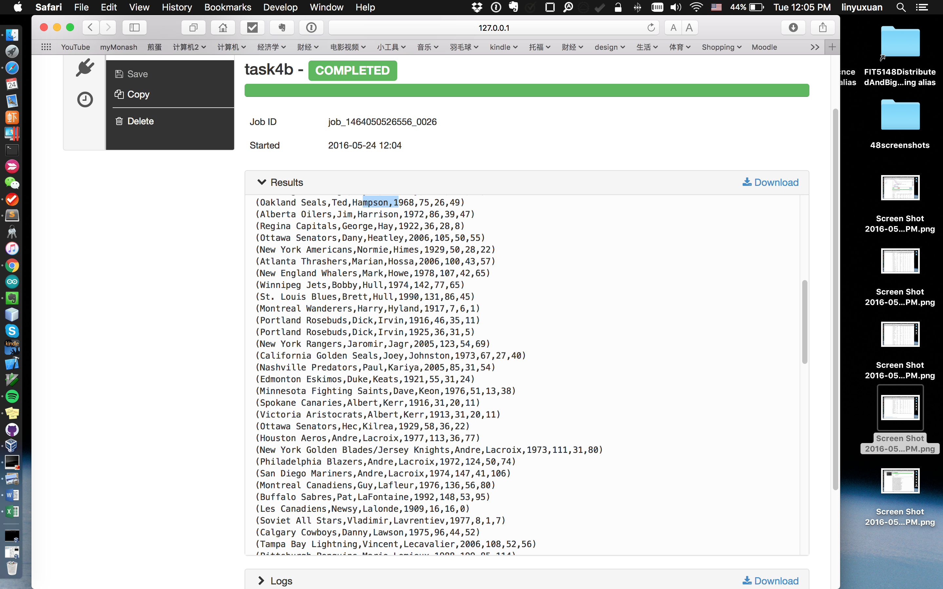
* 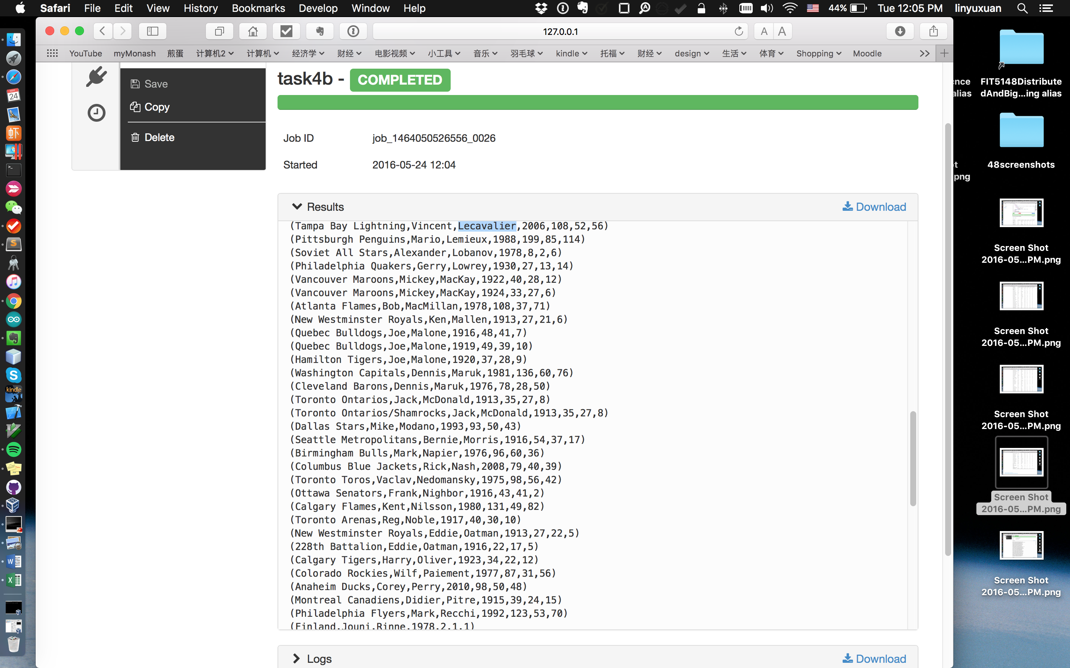
* 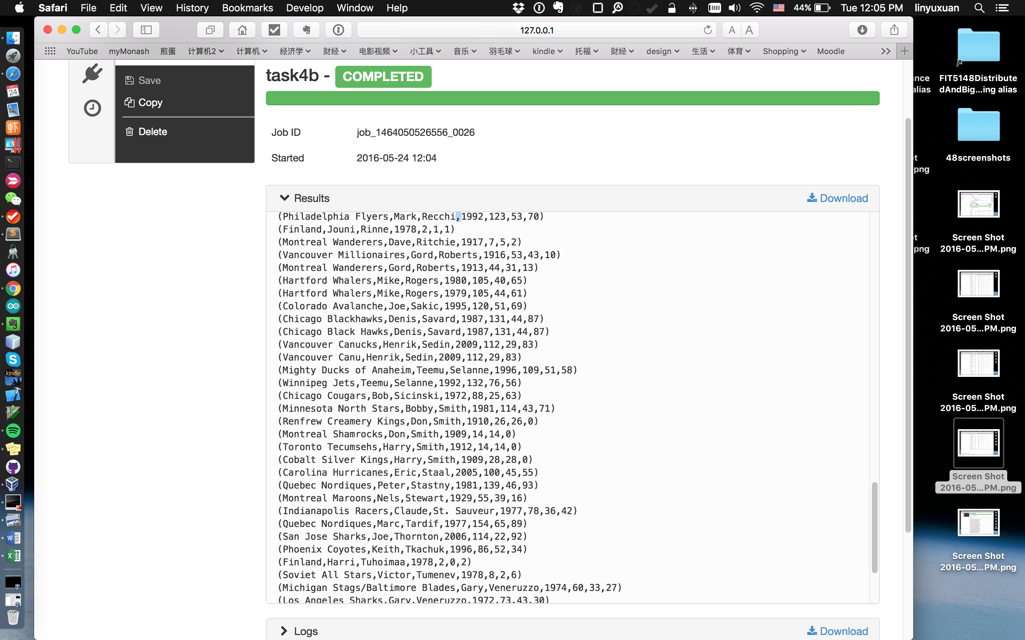
* 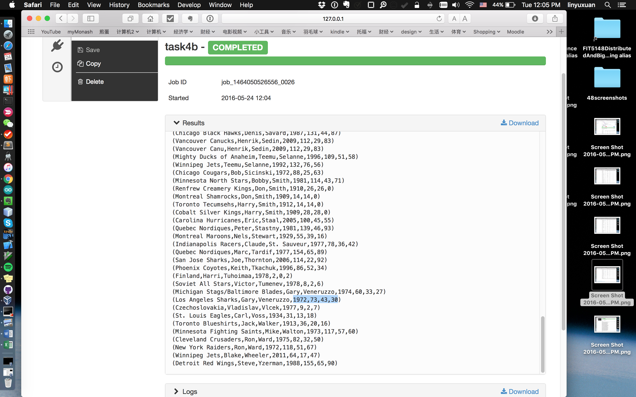
* Time consuming and details:
* Hive:
* 13 secs
* Run with Tez on, no maps and reducers.
* Pig:
* 1 min, 1 sec
* Run with Tez on, no maps and reducers.
* **Task 5 (3 marks):**
* − In the **Hortonworks shell**, execute the **first query in Task 3** using **Pig**, and record your  time with and without enabling the **Tez.** Compare the results.
* For without Tez:

Started At: 2016-05-22 12:13:32

Finished At: 2016-05-22 12:15:25

Time consumed: 1:53

With Tez:

Started At: 2016-05-22 12:25:47

Finished At: 2016-05-22 12:26:06

Time consumed: 0:19

* With Tez the process is shorted from 1 min 53 second to 19 seconds.
* − Then, in **Ambari, for Hive**, enable the Tez and perform the same query (the first query in  Task 3) with and without Tez, and compare your results.
* No Tez:
* 
* With Tez:
* 
* With Tez the process is shorted from 94 seconds to 14 seconds.
* − For the same query, for Hive, this time use **Cost Based Optimization(CBO) with Tez on.**

In this part, I fully understand the example in tutorial material, and follow the instructions provided in the material to do my assignment. But it always prompts “missing statistics” to me. I guess it should be a bug or some other platform problem which not mentioned in the material. After the discussion with my tutor, I provide my scripts used to optimize the query and to prove my effort in this question.

Hive script:

SELECT

pre.maxawards, master.firstname, master.lastname, master.birthyear, master.birthmon, master.birthday, master.birthcountry

FROM

(SELECT max.maxawards as maxawards, awardscounts_2.coachid as coachid

FROM

(SELECT count(award) as num_awards,coachid

FROM awardscoaches

GROUP BY (coachid)

) awardscounts_2

JOIN

(SELECT MAX(awardscounts.num_awards) as maxawards

FROM

(SELECT count(award) as num_awards,coachid

FROM awardscoaches

GROUP BY (coachid)

) awardscounts

) max

ON (awardscounts_2.num_awards = max.maxawards)

) pre

JOIN master

ON ( pre.coachid = master.coachid)

;

Analysis script:

ANALYZE TABLE awardscoaches COMPUTE STATISTICS;

ANALYZE TABLE awardscoaches COMPUTE STATISTICS FOR COLUMNS coachid, award;

ANALYZE TABLE master COMPUTE STATISTICS;

ANALYZE TABLE master COMPUTE STATISTICS FOR COLUMNS firstname, lastname, birthyear, birthmon, birthday, birthcountry;